TABLE OF CONTENTS

Presented by: Jacqueline Radtke

North Western MIchigan College

1701 East Front Street, Traverse City, MI



User Manual

Perceptual learning modules

Version 1.1

August 16, 2016

Getting Started 3

Introduction 3

Registration 3

Login 6

User Settings 7

Reporting a Module 7

Viewing Reports 8

Requesting Instructor Status 9

Module Creation 11

Creating a Module 11

Adding Answers 15

Adding Pictures 16

Adding Pictures 18

Image editing 20

Getting Started 20

Select an Image 21

Controls 23

Confirmation 31

Game Play 33

Getting Started 33

Settings 34

Game Play 36

Game Completion 42

Administration 44

Overview 44

User Administration 44

Create a User 44

Edit User Information 48

Change User Status 50

User Instructor Requests 53

Roles 55

Modules 59

Edit 59

Disable/Enable 62

Delete 64

Reports 65

Getting Started

# Introduction

Creating modules is how instructors teach users of the site. This can range from academic courses, to job training, to even a game designed specifically for fun. A module is a collection of related, but different pictures, focused around a similar theme. For example, the user may be trying to identify cats and are shown a picture of a house cat, a puma, a lion, a bobcat, and a tiger. All are pictures of cats but have different variations that would make them a bit different. Someone has to understand that the similarities outweigh the differences. Modules help learners to understand that a lion is still a cat by associating the ideas together for the learner with different pictures connected to one idea.

# Registration

## Access the PLM Website

* 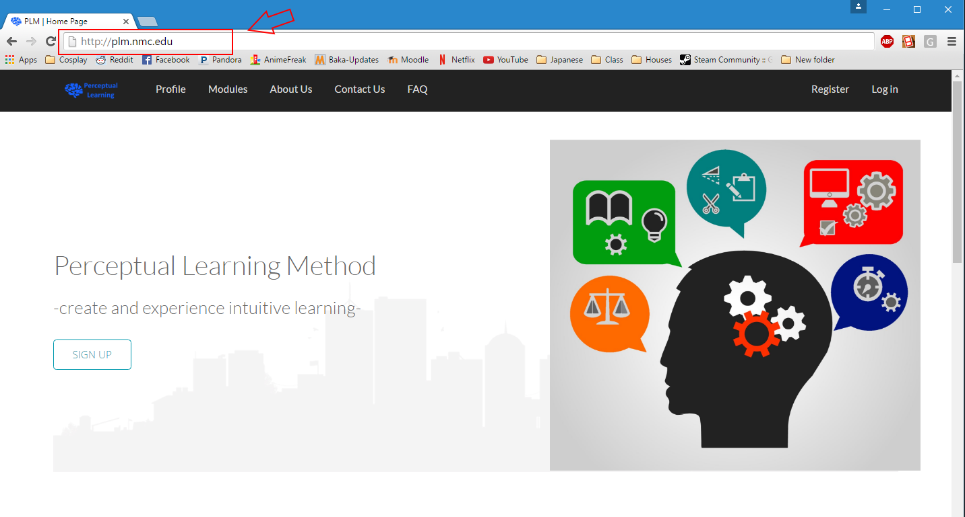Type in http://plm.nmc.edu/perceptuallearning in the browser or follow a link to find the webpage.

## Register

* Click on the Register page in the top right hand corner and fill in your first name, last name, institution, and email address.

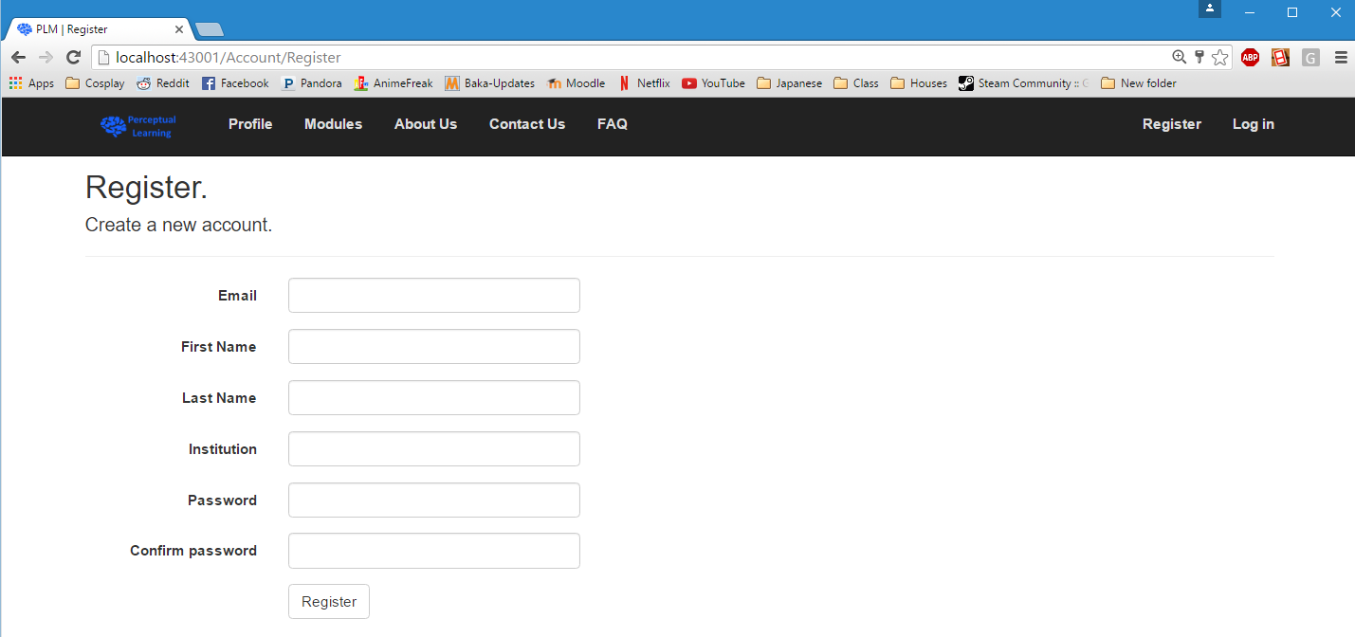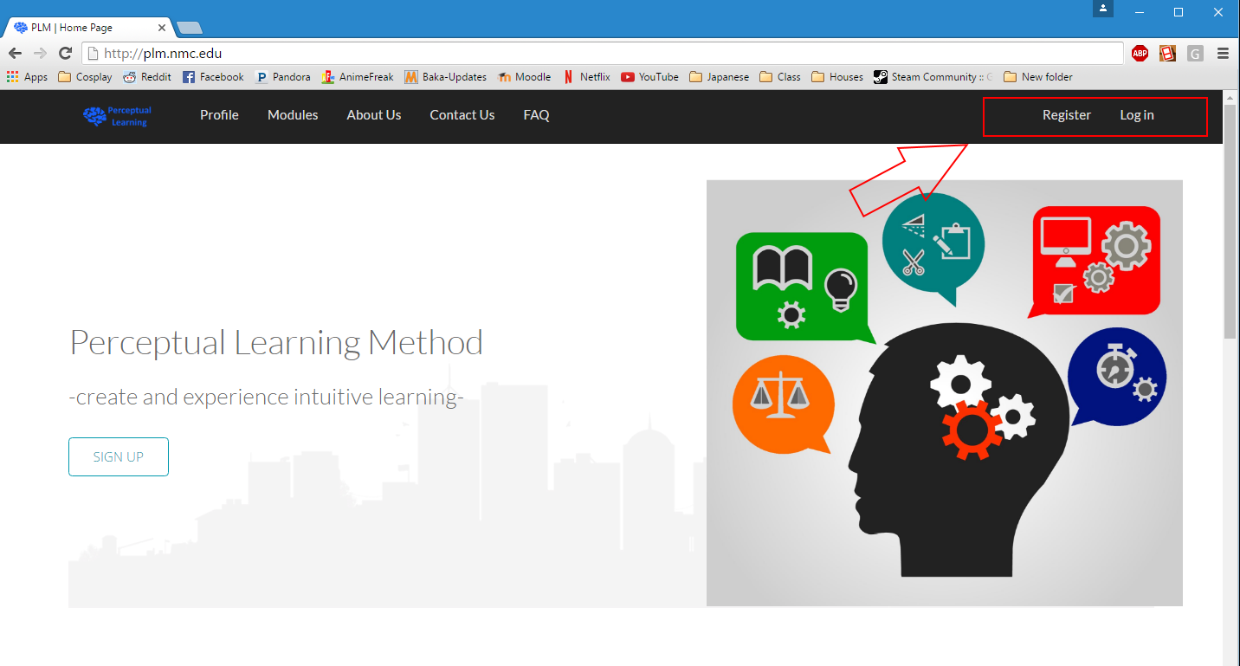

# Login

## Go to Login page

* 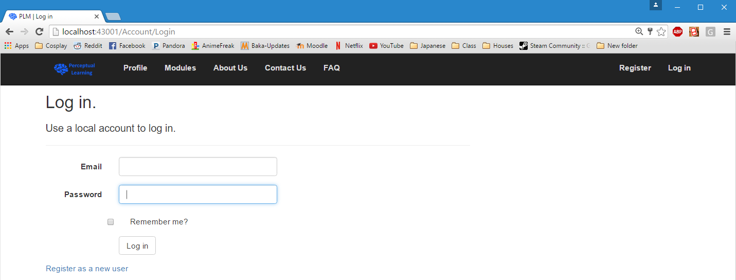Find the link to the ‘Login’ page found in the upper right hand corner of the screen from the home page.
* You will be navigated to the ‘Login’ page.
* Click the ‘Log in’ button at the bottom of the page to login.

# User Settings

## reporting a module

* There are several reasons you should report a module. If a module breaks copyright law, has inappropriate content/profanity, or if the module information you should report a module. Doing so notifies the creator of the module as well as admins so action can be taken to fix the problem.
* 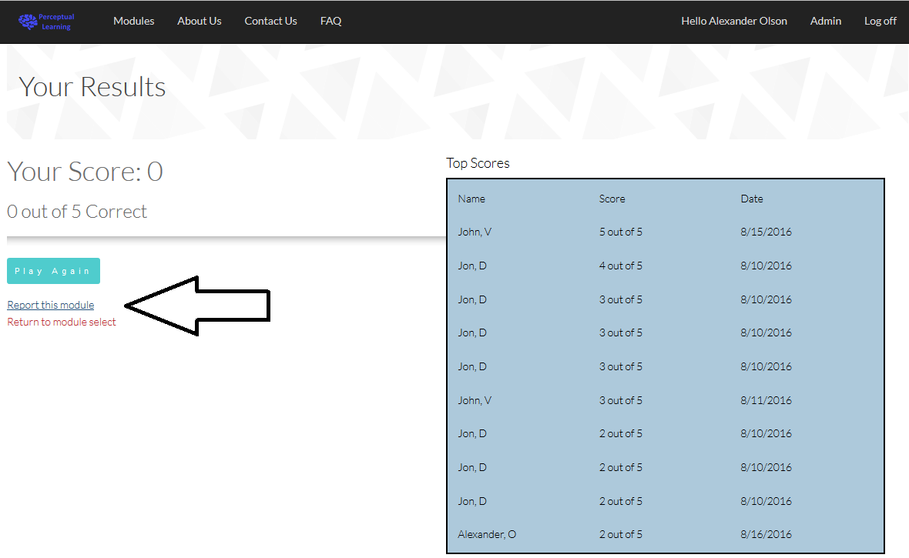To report a module, upon completion of the modules click the report this module link.
* Upon doing so it will bring you to a page where you can type out the reason for the report and select a category. Once you are done click the create button to send the report. All other necessary information is automatically generated and added to the report. (Module that was reported and who reported it).

## Viewing open Reports

* 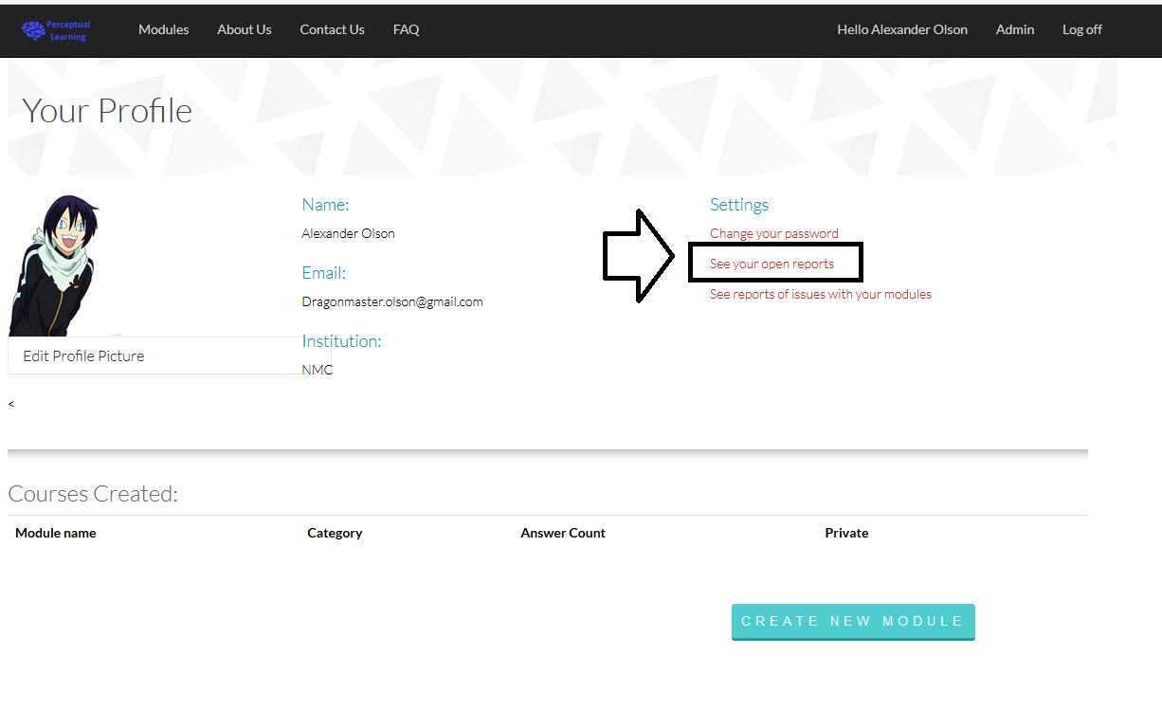In order to view reports that you have made on modules you need to go to your profile page and click view reports.
* 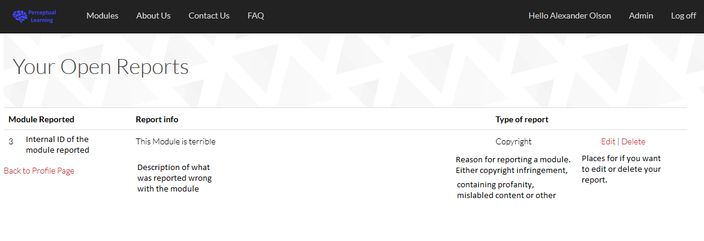While in the reports view you can see the description, ID, and reason for reporting the module. and choose to edit or delete your reports if needed.

# Requesting Instructor Status

* 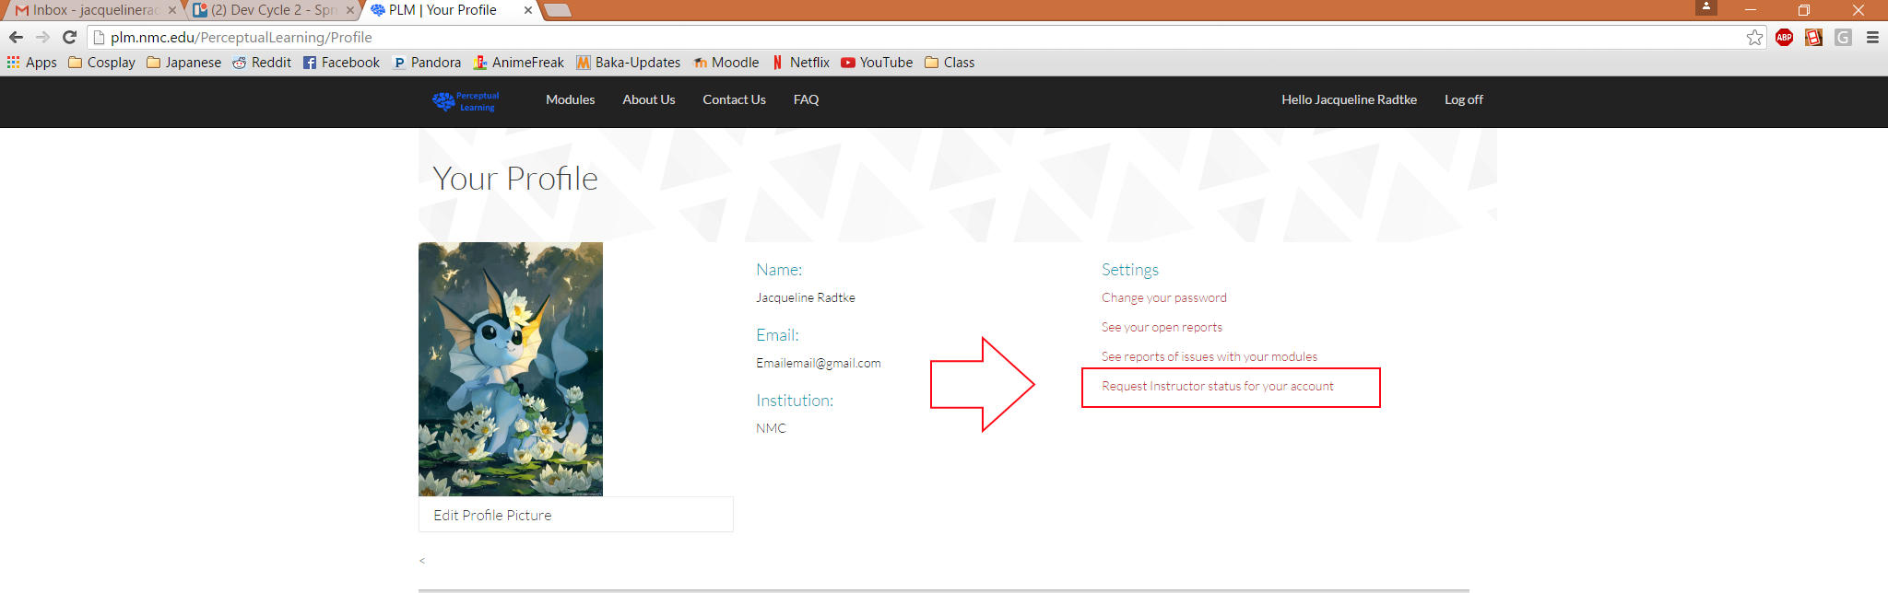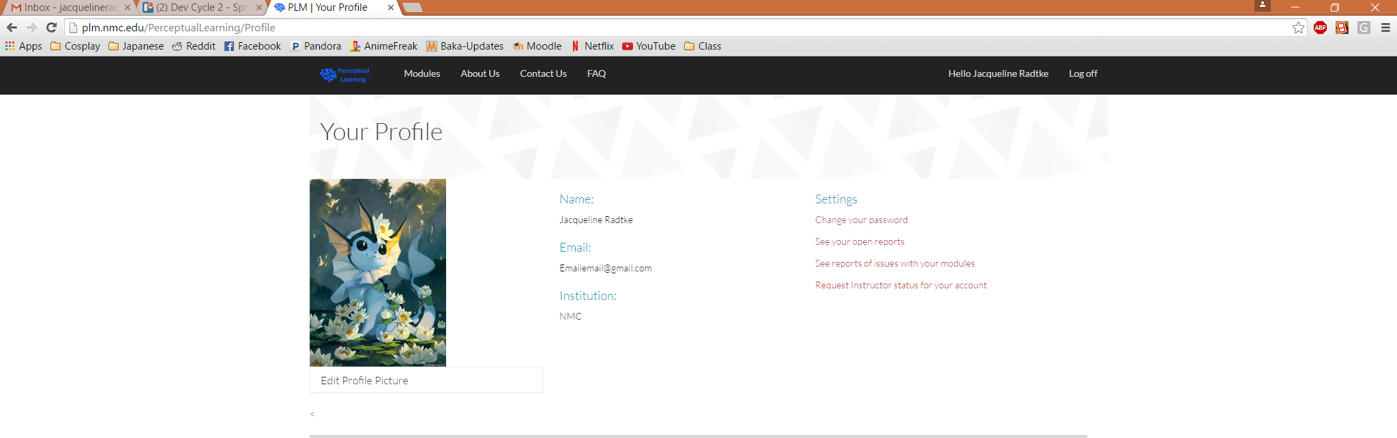Navigate to your profile page.
* Then click on the ‘Request instructor status for your account’ link under the settings menu.
* 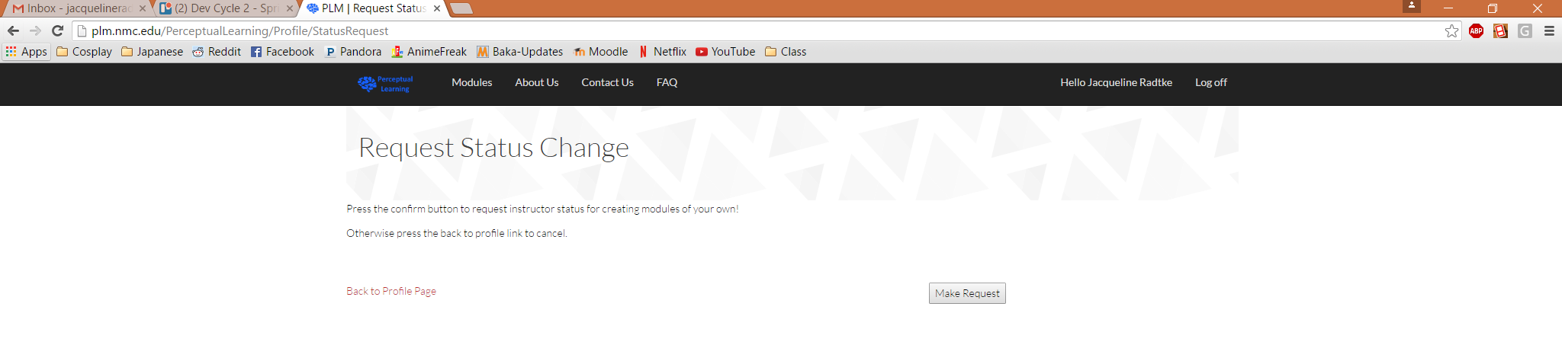You will be navigated to the 'Request Status Change’ page.
* 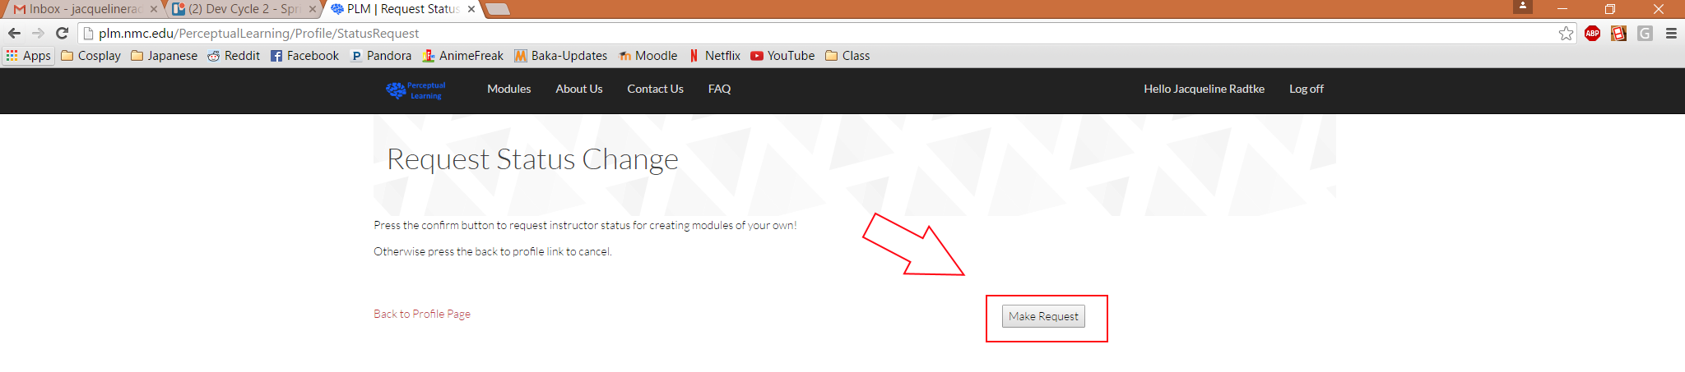Then click the ‘Make Request’ button to submit your request.
* You will be navigated back to your profile page.
* Once an administrator has approved your account you will become an instructor. This will give you the ability to create modules from your profile page.

PLM Creation

# Get Started

* Access the PLM Website.
* Make sure to login or register for a personal account (see ‘Getting Started’ Section).
* Access your Profile Page.
* 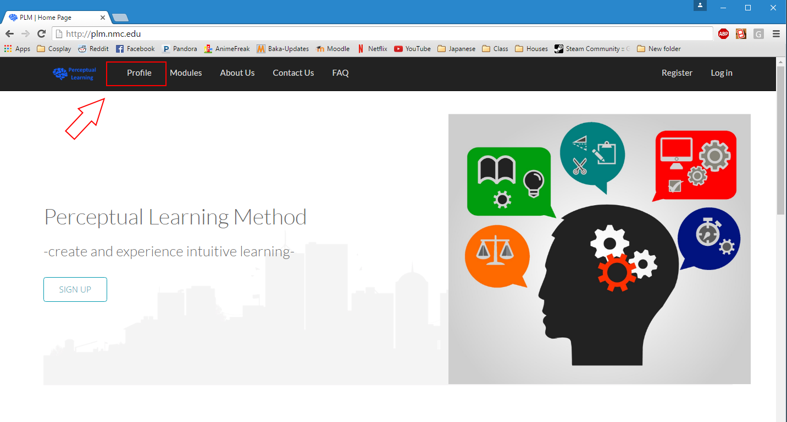Navigate to your profile page found in the Navigation bar at the top of the screen. You should see your information and profile picture here.
* 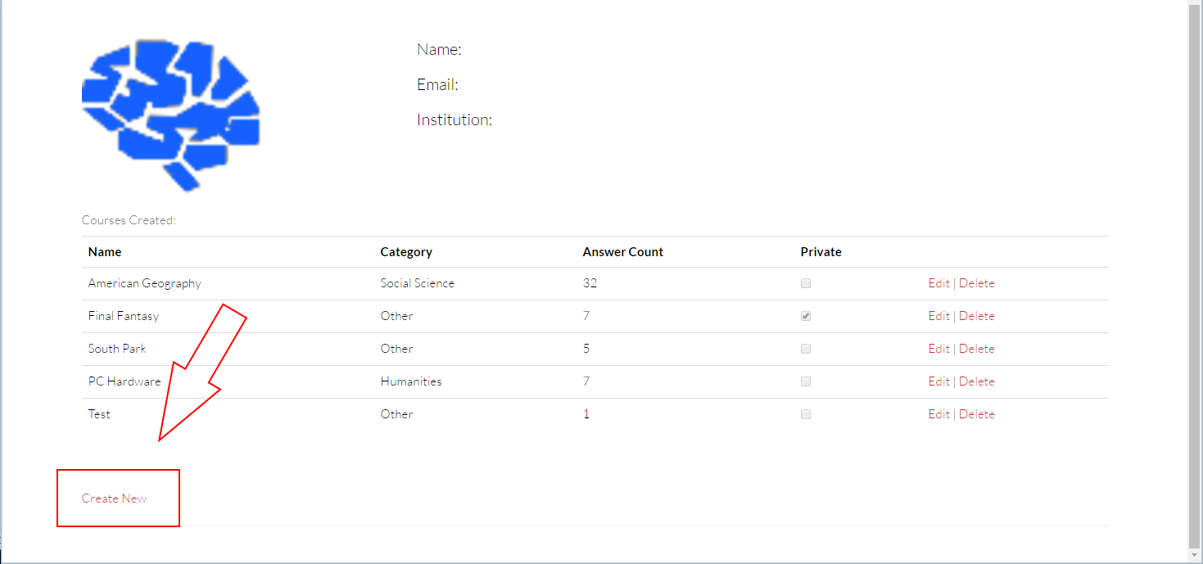You will find the ‘Create New’ link at the bottom of the page to start a new Perceptual Learning Module.

# Add Basic Information to a PLM

* Once you click the ‘Create New’ link from the profile page, you will see the PLM creation page.

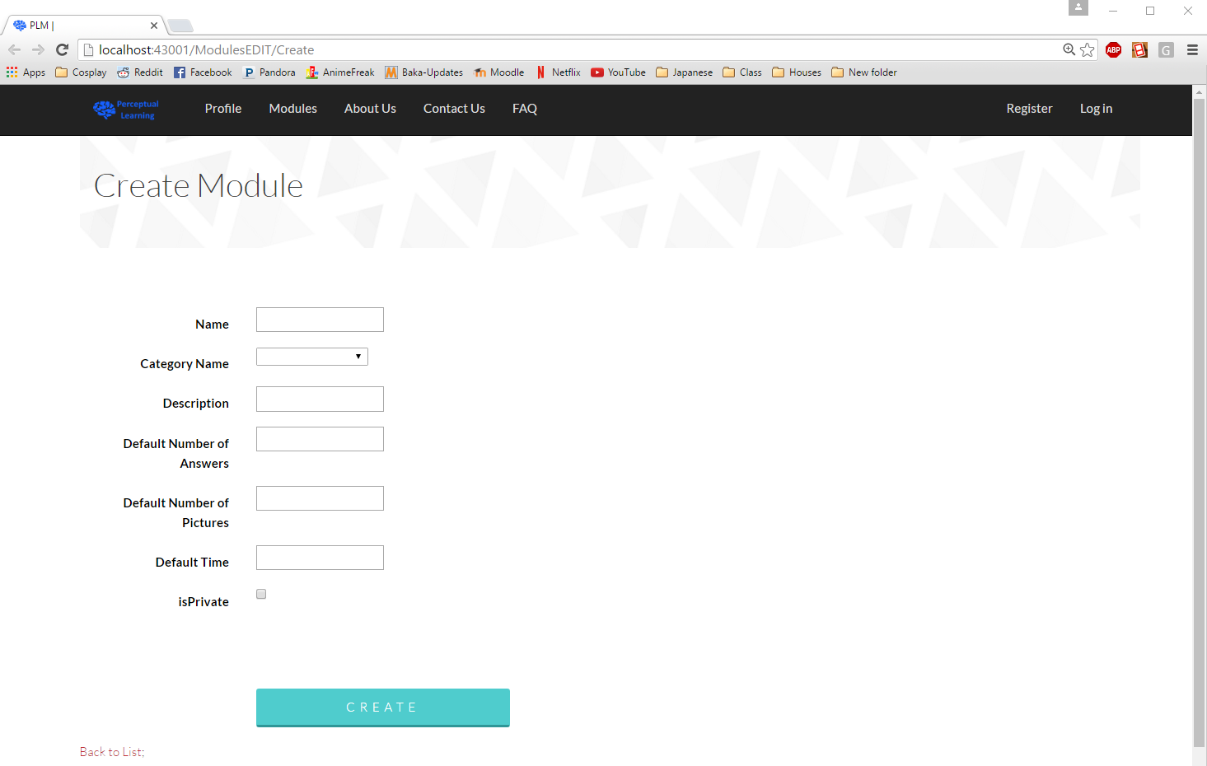

* Enter a Name for your module. Make sure to be sort and descriptive. This is what people will see while searching to play your module.
* Enter a Category for your module. A category lets users find your module and other like modules as a type of search criteria. Try to make sure that your module has as close as possible the correct category so that a user has a better chance at finding your module.
* Enter a Description for your module. This will let players know what your module is about and what someone will be able to learn by playing your module.
* Enter a Default Number of Answers for your module. This number will change the number of possible answers at the bottom of each question based upon what you set. A lower number will make the module easier and a larger number will make the module harder.
* Enter a Number of Pictures for your module. This number changes the how long the module will be for your players. The lower the number the shorter the module will be and the larger the number the longer the module will be.
* Enter a Default Time for your module. This number will change the time limit for a player to complete a single play through of a module in minutes.
* Decide if you want your module to be Public or Private. A private module will not be able to be played and is not open to the public. This setting would be used if you do not want others to see what you are working on.
* 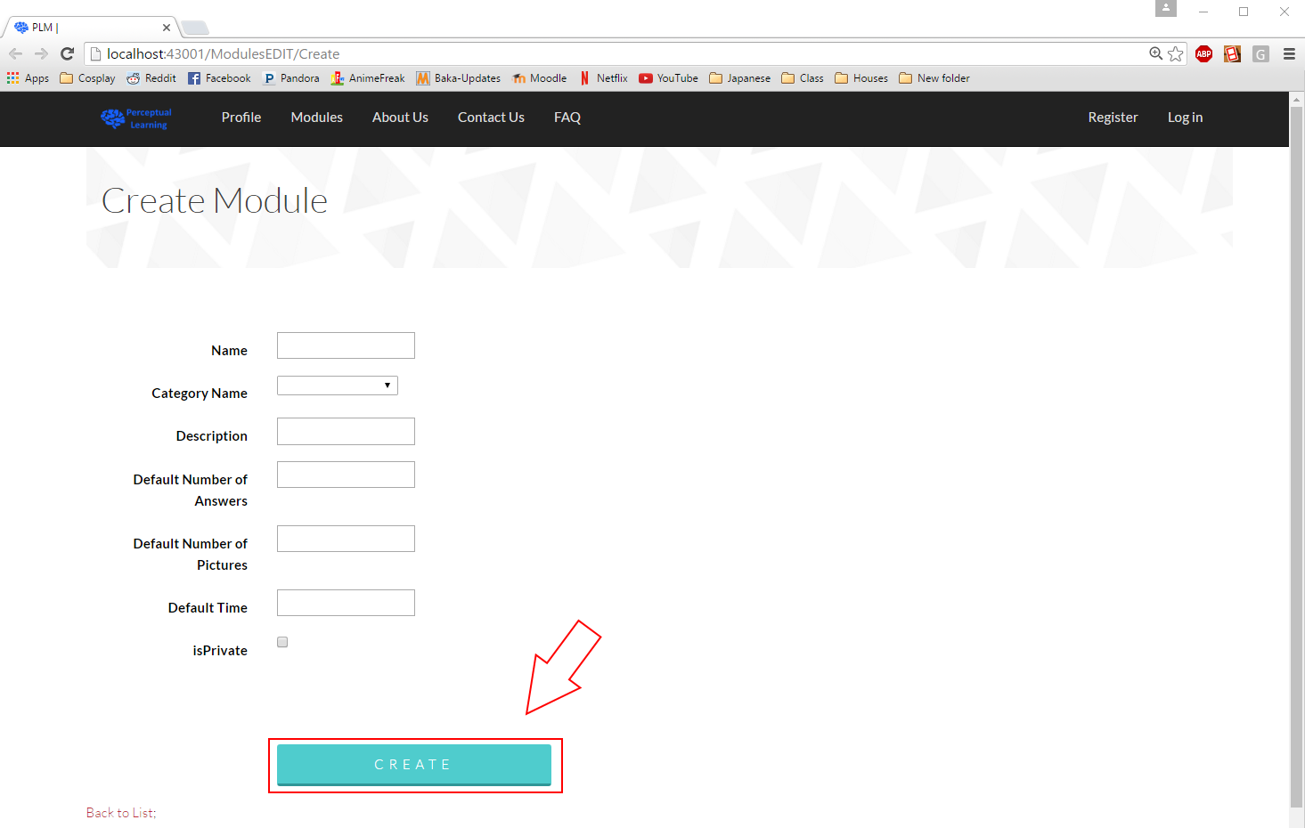Once you are finished with each setting then you can click the ‘Create’ button to save your new module.
* You will then be sent back to your profile page where you can make any changes to your module and continue adding to it.

# Add Answers to your Module

* 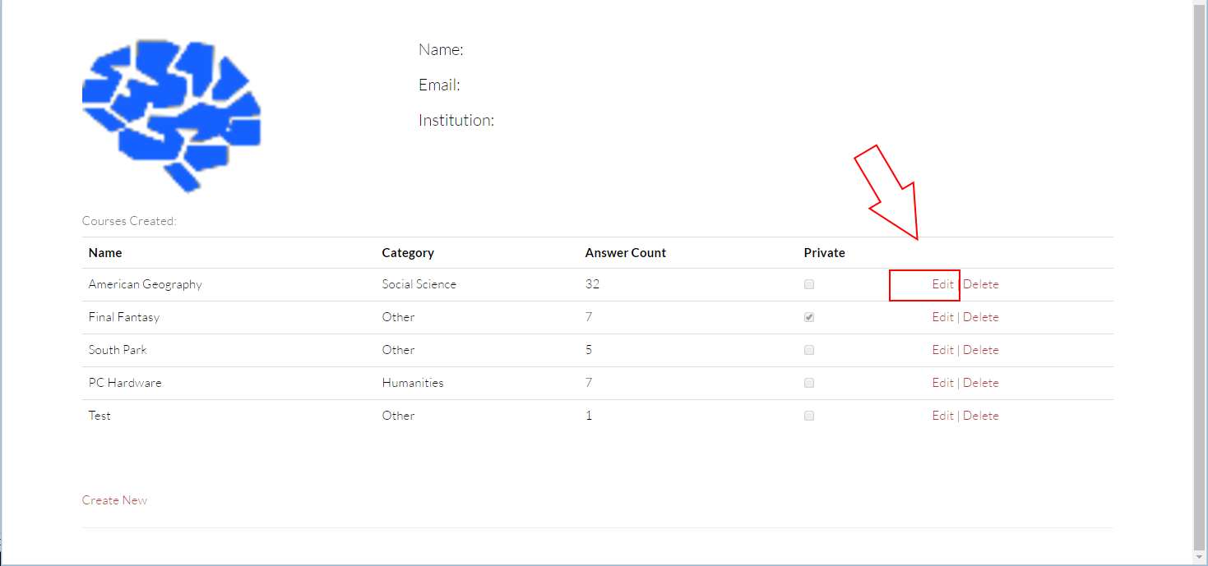On your profile page click the ‘Edit’ link in the same row as the module that you would like to make changes to.
* 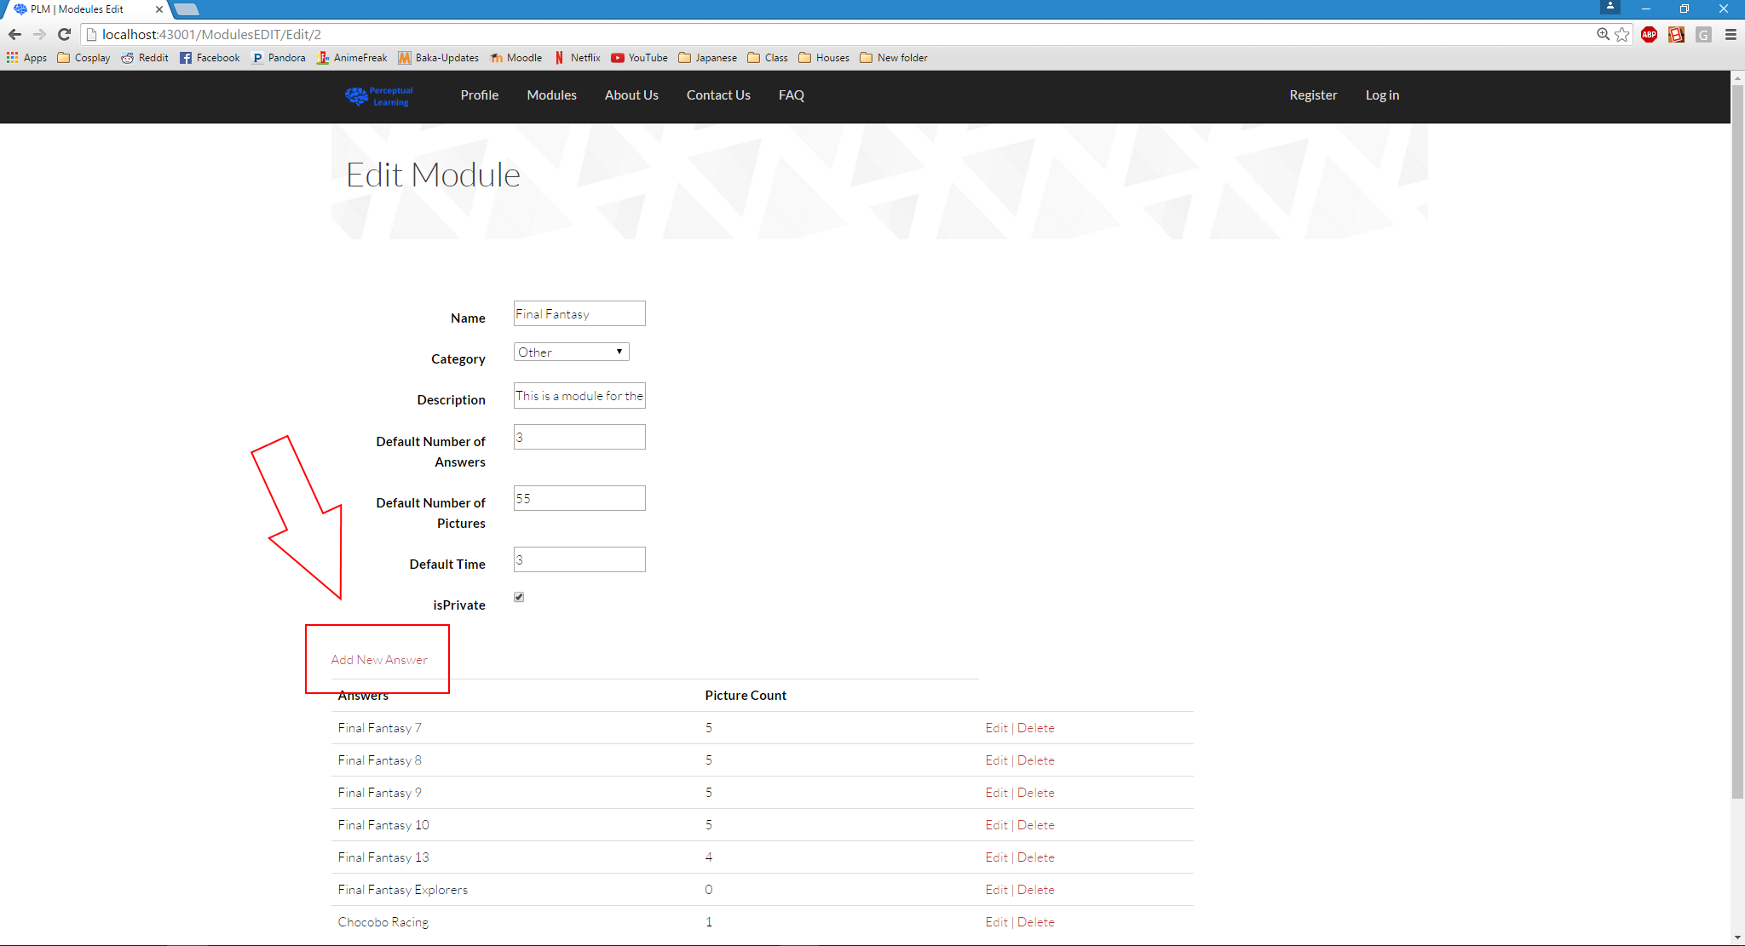Once on the Edit PLM page, click the ‘Add New Answers’ link to create a new possible answer.
* 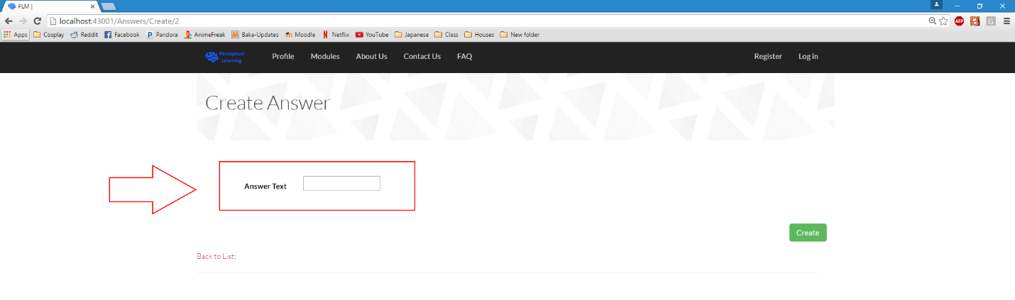Enter an Answer String for your answer. This is what will appear as a possible answer in a perceptual learning module as a button. Try to make this string as short as possible.
* 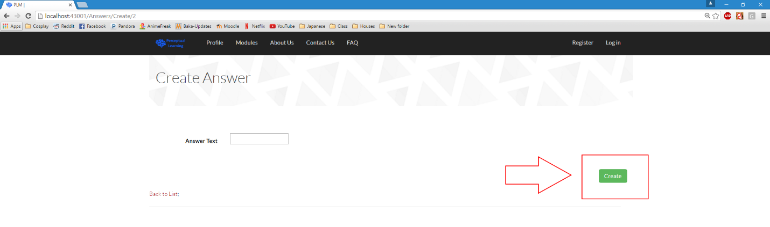When you are satisfied with your Answer String, click the ‘Create’ button in the lower right hand corner to create your Answer.
* Follow this process as many times as you need to in order to complete your module. Remember that the more Answers there are the better.

# Add Pictures to your Answers

* On the Module Edit page, you will notice Edit and Delete links in each row after each answer.
* Click on the ‘Edit’ link to edit the answer.

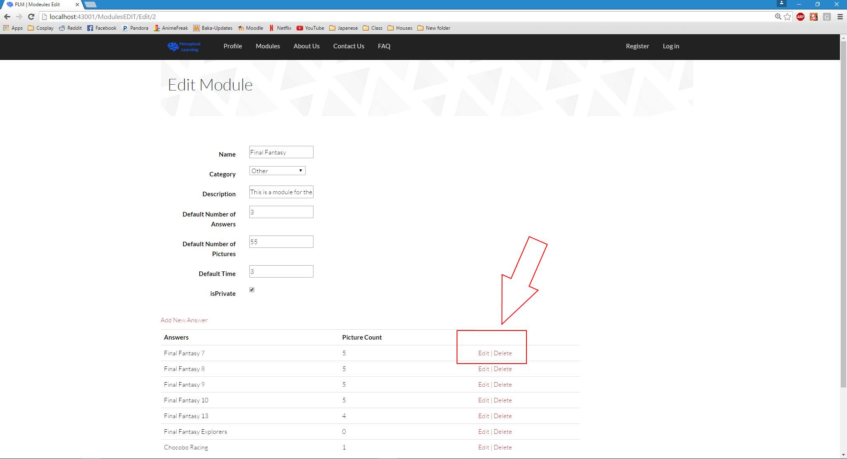

* 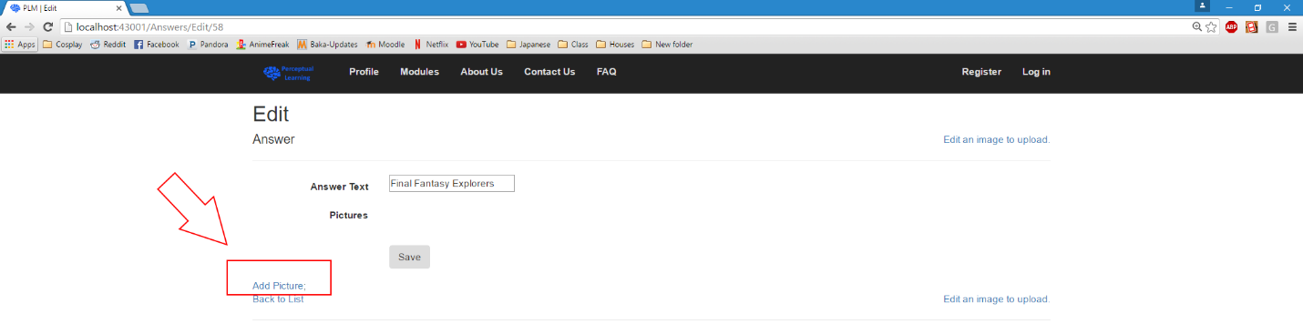Click on the ‘Add Picture’ link in the lower left hand corner to add a picture that will be associated with the selected answer.
* Click on the ‘Choose File’ button to search your computer for a picture that you would like to upload that will be associated with the selected answer.
* 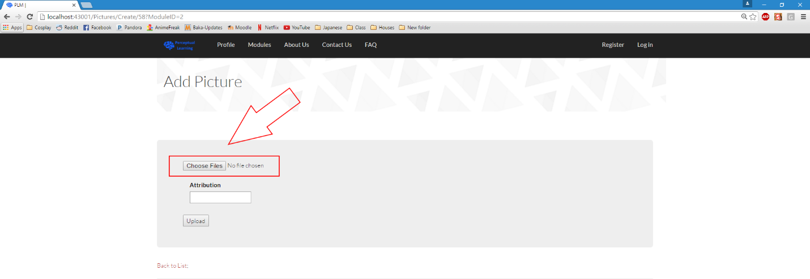Once you have selected an image to upload, if the picture has copy written material then you must use the attribution field to give credit to the owner/creator of the image.
* 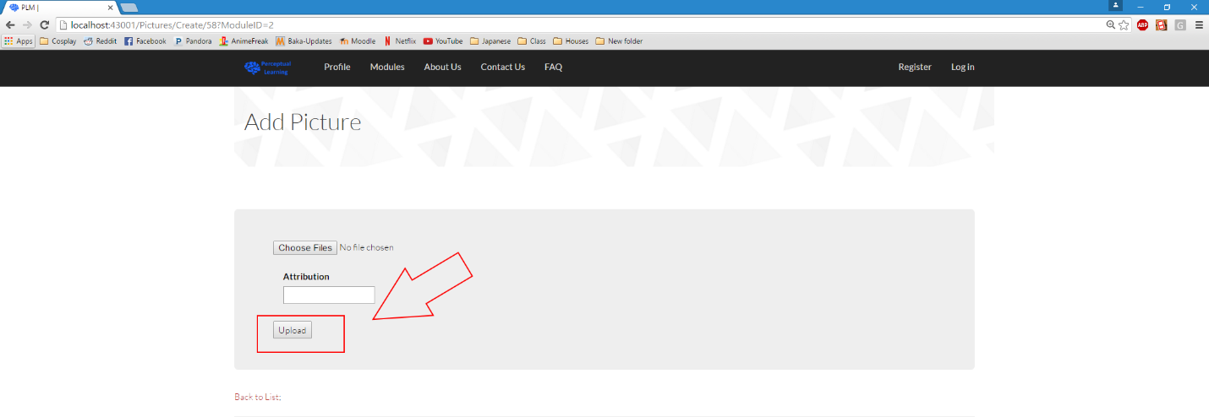Once you are finished and ready to upload your picture then you can click the ‘Upload’ button to save the picture and its attribution to your module.
* Follow this process as many times as you need to in order to complete your module. Each answer should have as many pictures as possible in order to fulfill the idea of perceptual learning.

# Test your Module

* From your profile page click on the module name that you will to play out of the list of modules that you have created.

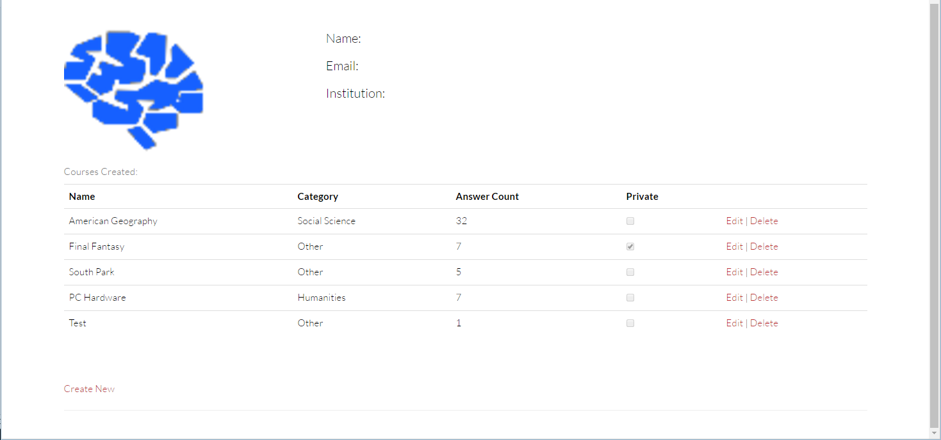

* Make sure the pictures are displaying as you would like to appear.
* Make sure that the default time is enough to finish the perceptual learning module.
* Make sure that the module is of a length that you deem as appropriate.
* Enjoy your creation!

Image Editing

## Getting started

* At the top of the webpage, there is a big black bar with links. If you aren’t logged in, there will be a link that says ‘Log in’. If you are, there will be a link that says ‘Hello [YOUR USERNAME]’, where ‘[YOUR USERNAME]’ is replaced by your username.
* If you aren’t logged in, do so. Then, once you are logged in, click your username to be taken to your profile page. (You won’t see the ‘Admin’ link, because that’s only for admins like me!)



* At your profile page, click the edit link for the module that has the images you want to edit.

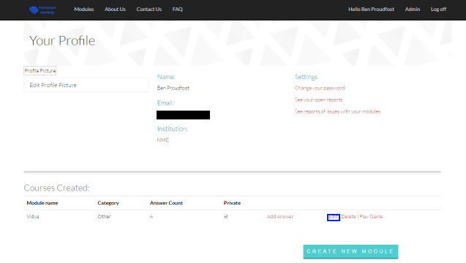

* Now you are at the Edit Module page for your module. At the bottom of the page, select the ‘Edit’ link for the answer that has the picture you want to edit.

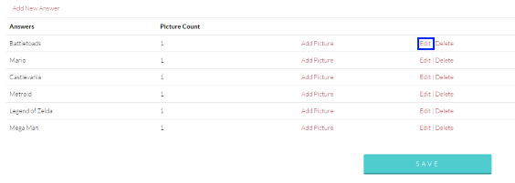

* Step 1: Now you are at the ‘Edit Answer’ page. Select the ‘Edit this image’ link below the image you want to edit.

## Select an Image

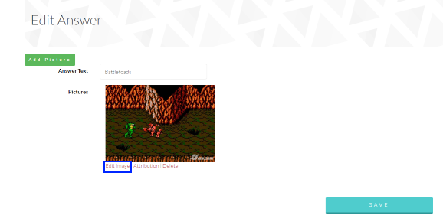

* Step 2: Read the instructions above the image, they’re important, as they’ll tell you what format to save it as.

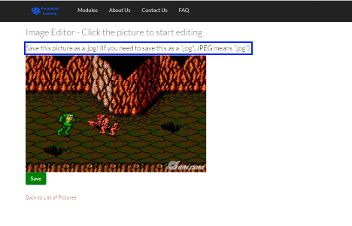

* Step 3: Open the image editor by clicking the image.

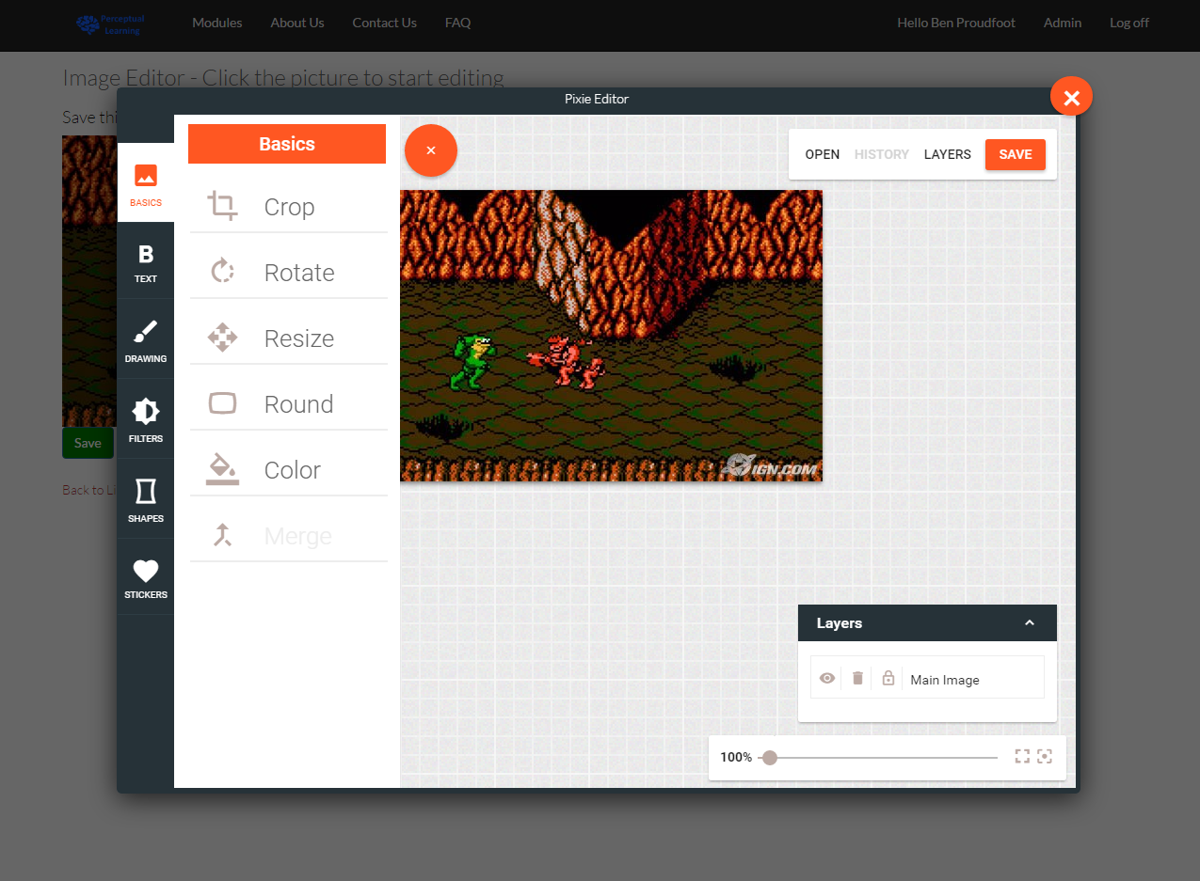

## Controlls

* Step 4: Use the options on the left hand side to edit your image! Draw lines, squares, and circles, write text, resize, and crop images. Let’s look at how to draw a rectangle first.

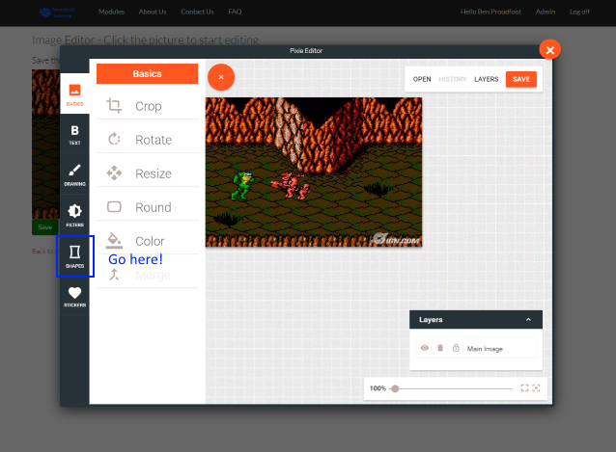

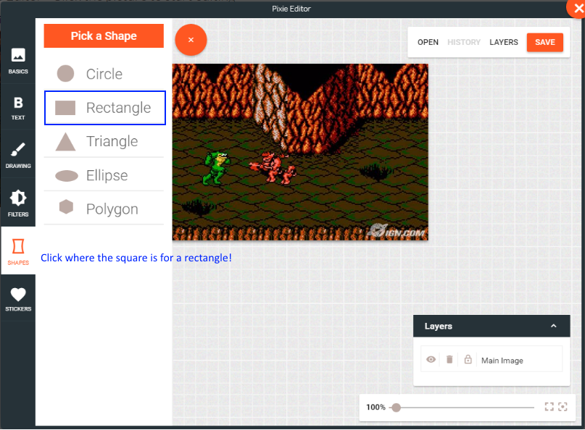

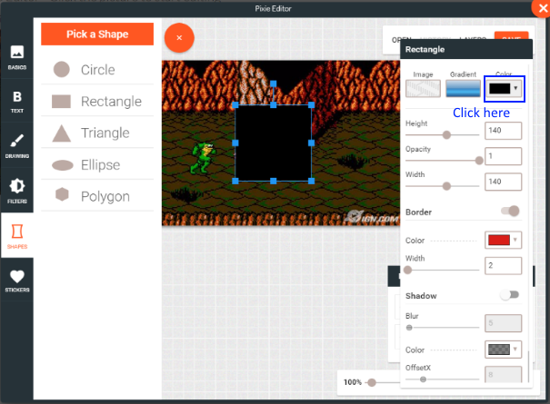

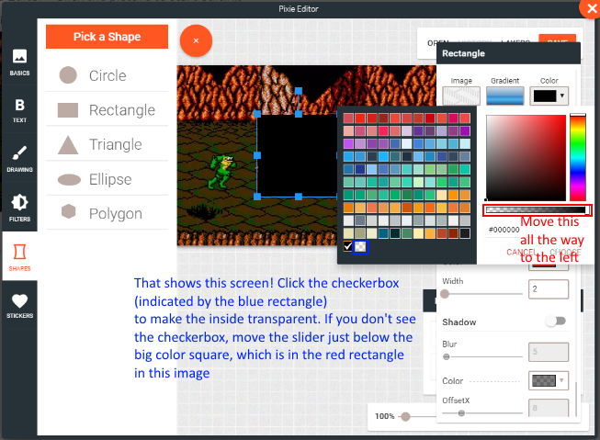

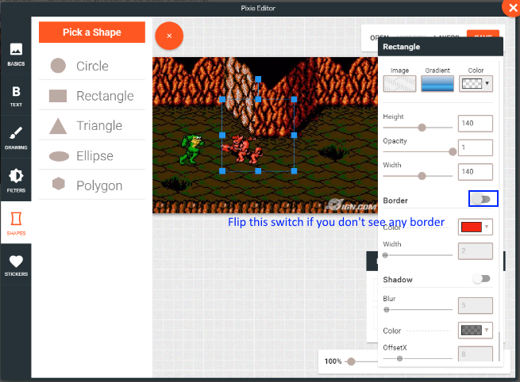

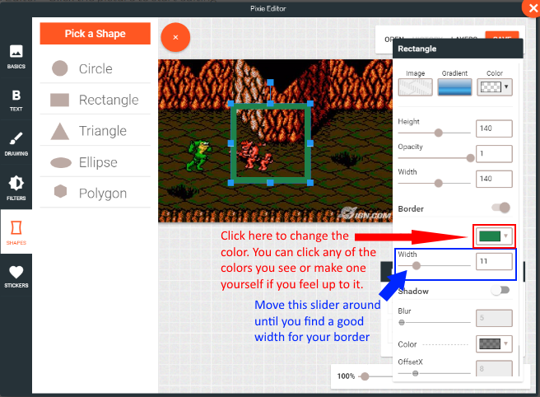

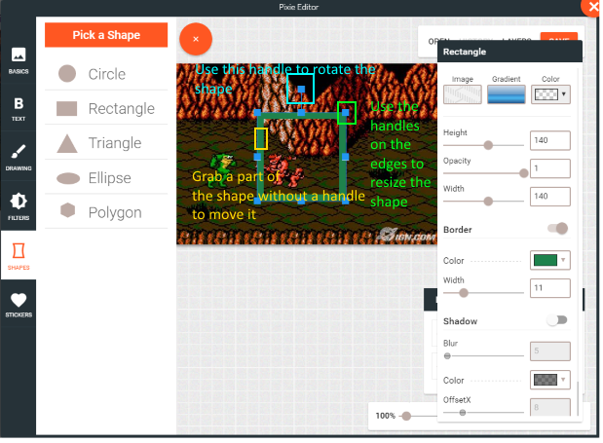

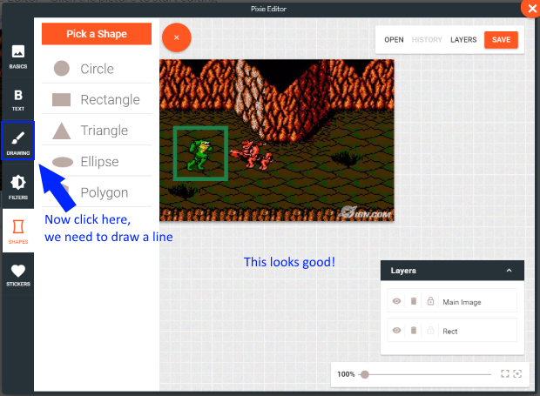

* Note: You can apply the process you used to make a rectangle to any other shape, too!

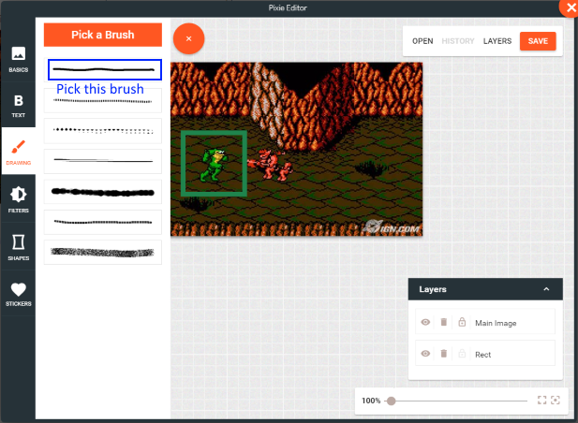

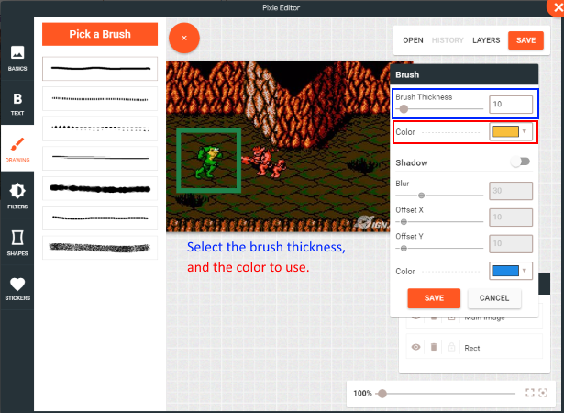

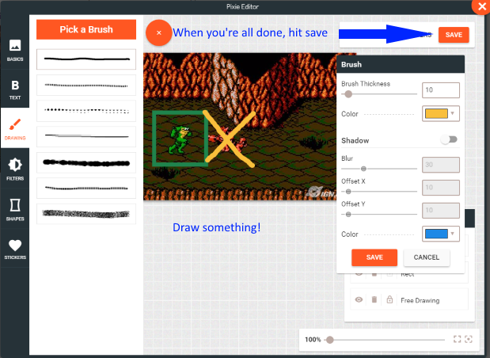

* Step 5: When you’re fine with the changes you’ve made, save the image, selecting the correct file extension. If you accidentally select the wrong extension, don’t worry. Click the image again, and save it as the correct file extension.

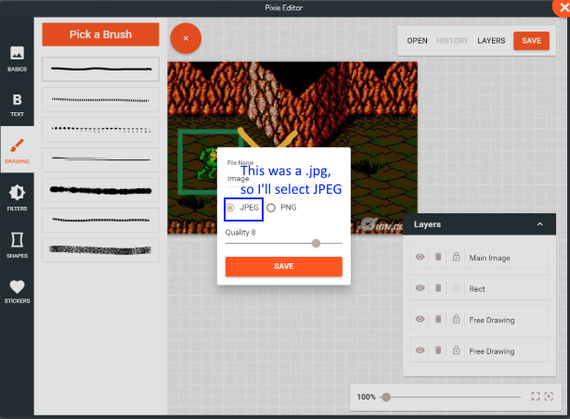

* Step 6: If you realized you forgot to add something, click the picture again to add more stuff. If you realized you made a mistake, click the “Back to List of Pictures” link, then reselect your image. It should be back to the way it was before you edited it. If you’re okay with the changes you’ve made, hit the green “Save” button to go to the confirmation page.

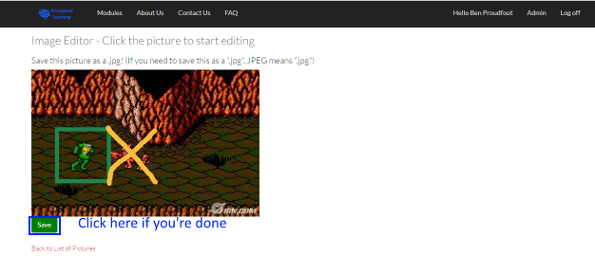

## Confirmation

* 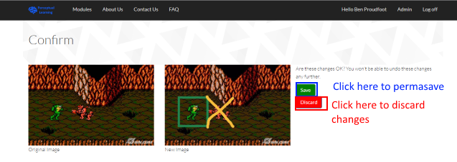Step 7: At the confirmation page, you’ll see your old image side by side with your new image. If you like the changes, hit “Save” to permanently save them. You can’t take this action back. If you don’t, hit “Discard”, and your image will stay without changes.
* Step 8: When you return to the list of pictures for the answer, you won’t see them initially, because the computer hasn’t been told there’s been a change yet. Refresh the page by hitting the refresh icon for your browser, or hit the F5 key. This gets an updated version of the page, which has your new changes.

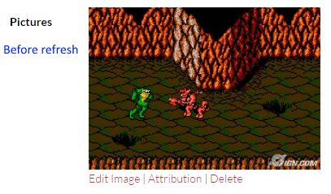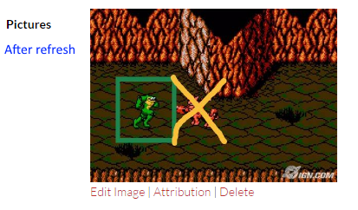

GamePlay

## Getting started

* At the top of the webpage, there is a big black bar with links. Click the “Modules” link, located right next to the site logo on the bar.

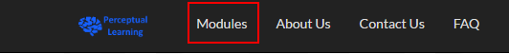

* You will be navigated to the ‘Module Select’ page.

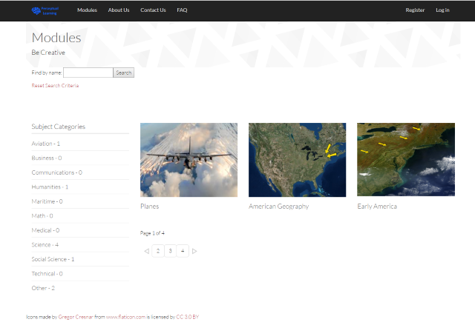

* Hover over a picture to display the two options for starting the game:

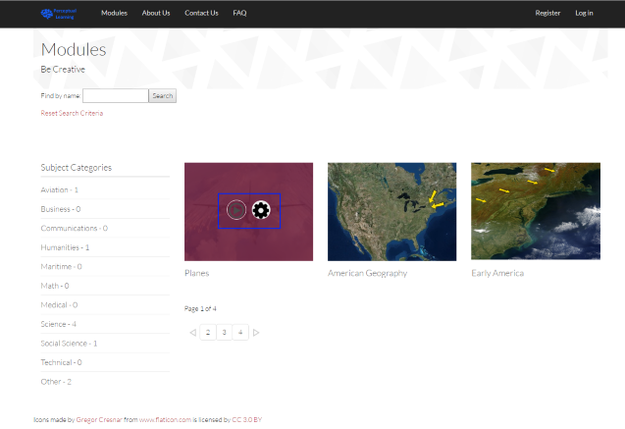

## Game Setup

* If you want to jump into the game immediately, select the ‘Play’ button. If you want to setup game options, select the gear icon to go to the ‘Settings’ page.

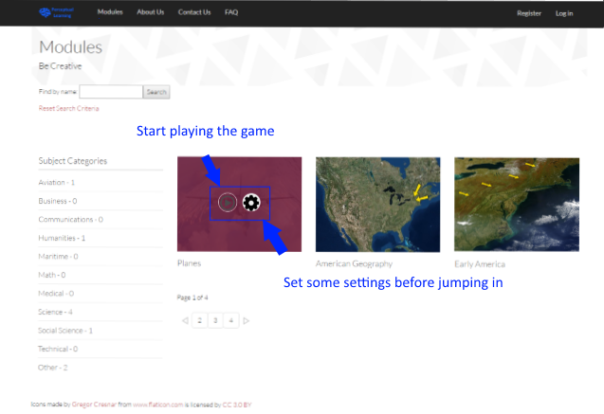

* If you selected the gear icon in the previous step, you will be taken to the settings page. In the settings page, you can set the amount of answers you can choose from, the amount of questions you want to answer, and the time limit. If you are using the Google Chrome web browser, the color for each slider will change from green to red based on how difficult the resulting game will be. When you are all done, click the large, green play button to start the game with those settings.

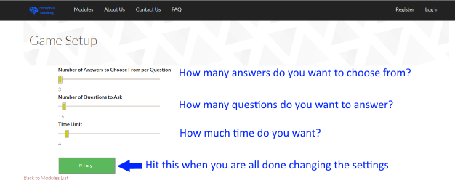

## Game Play

* Here is the gameplay screen. For this game, I chose to start off with answering ten questions in 32 minutes. I have three possible answers to choose from.

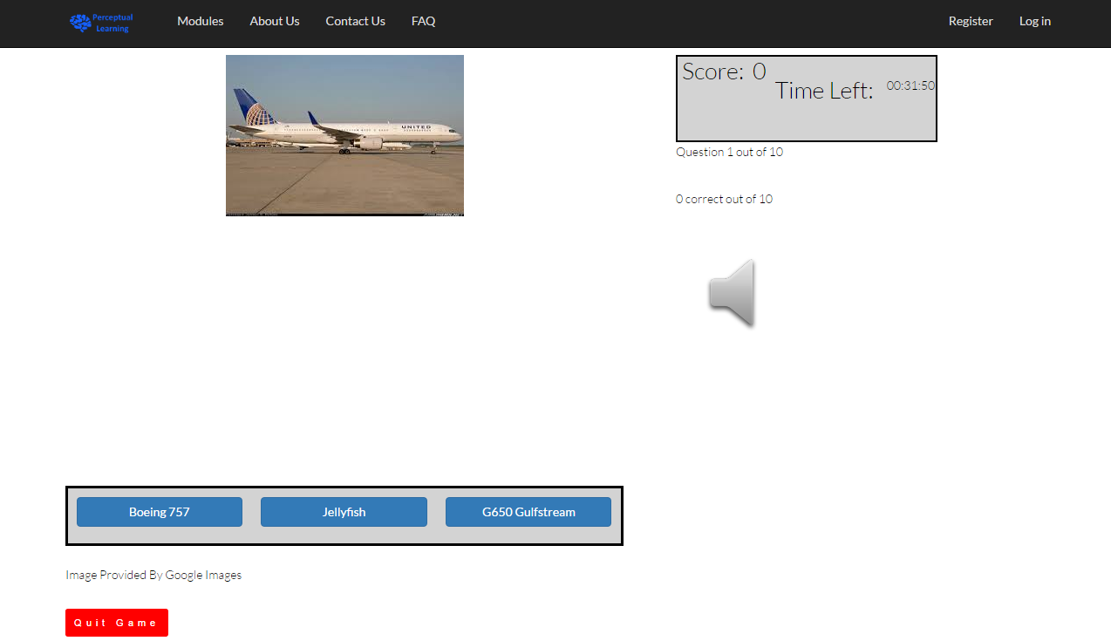

* For each picture you correctly identify, you will get one hundred (100) points. For each picture you incorrectly identify, you will get zero (0) points. Since I answered this question correctly, I got 100 points!

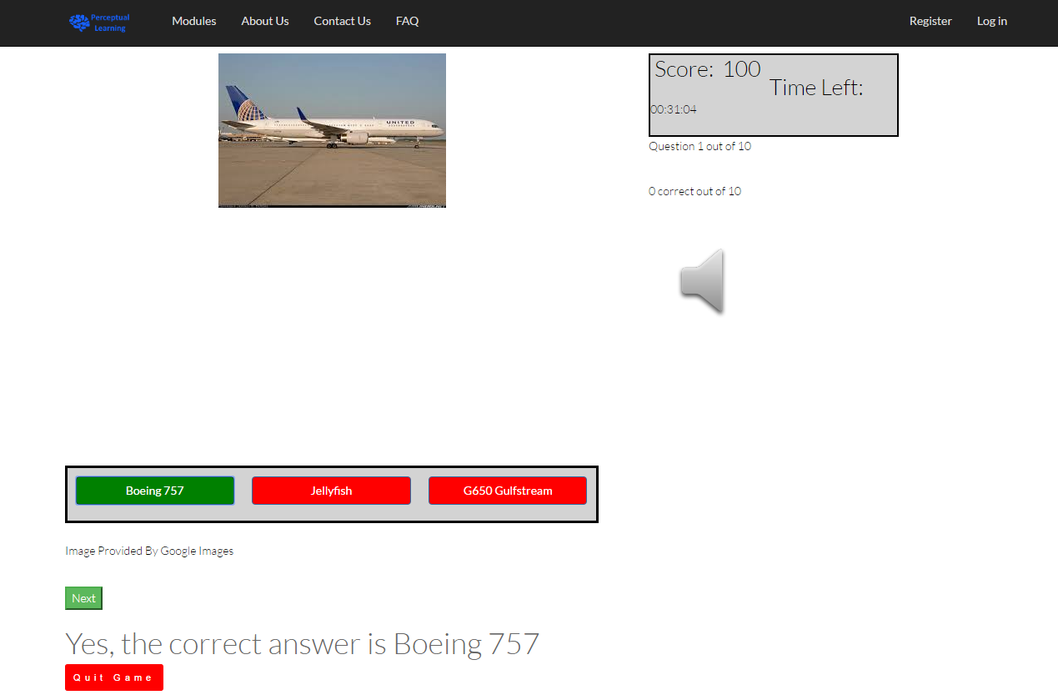

* The scoreboard shows your current score and the time remaining on the timer.

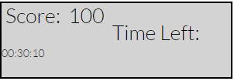

* The timer does not stop, unless the page is loading.
* If the timer hits zero, you will be kicked out to the ‘Game Complete’ screen.
* Your current stats, such as the number of questions you’ve answered correctly, will be shown just underneath the scoreboard.

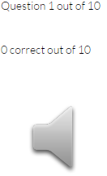

* Click the speaker icon to mute or unmute the sound.
* The speaker icon by itself indicates that the sound is not muted, while a speaker icon with an ‘x’ in front of it indicates that the sound is muted.

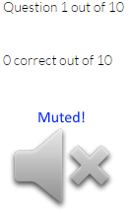 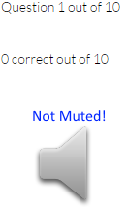

* Once you have decided on an answer you think is correct, click it. I think this one is a picture of an AC-130 Lockheed.

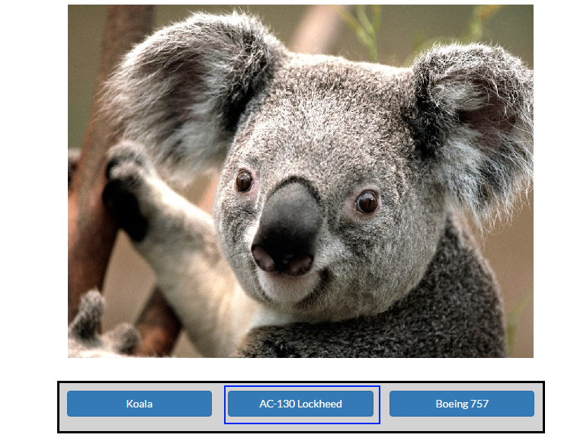

* The game will play a sound (if the sound isn’t muted) and display text indicating if you were correct or not.

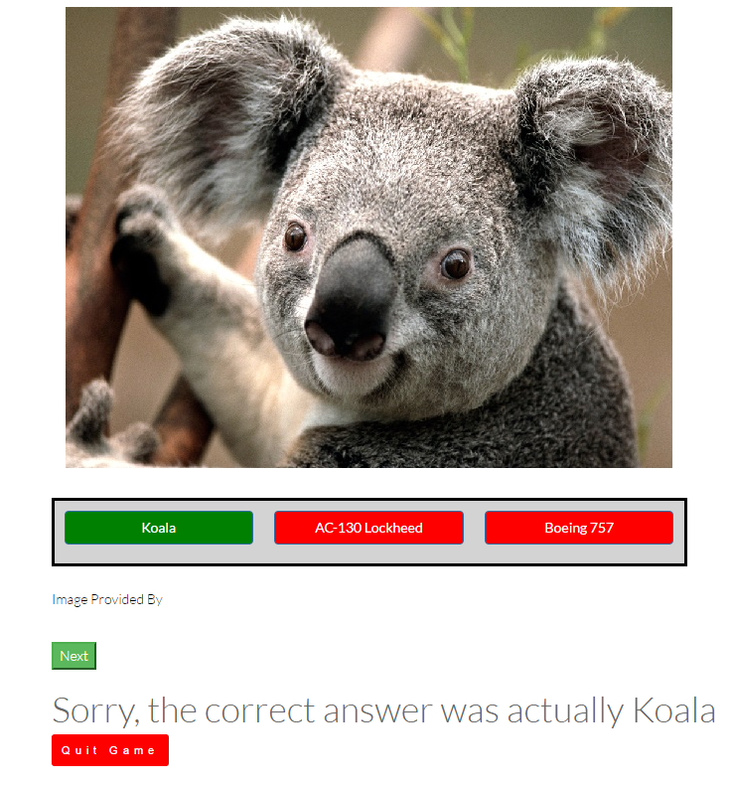

* To move on to the next question, press the ‘Next’ button.

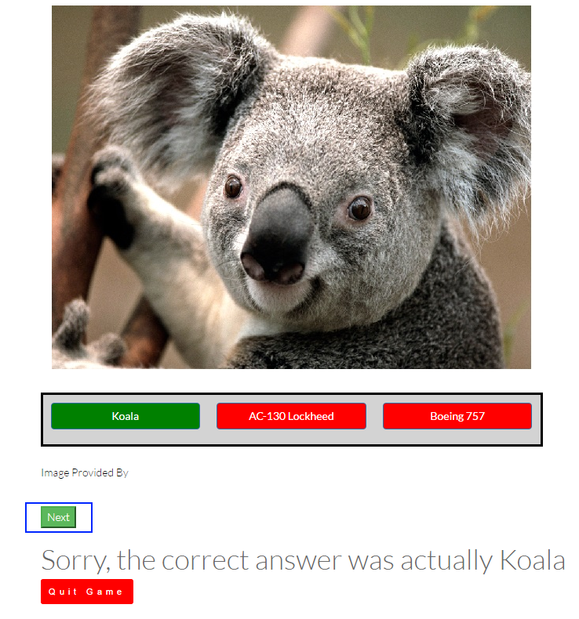

* Click ‘Quit Game’ to quit the game. Your progress will not be saved if you do this.

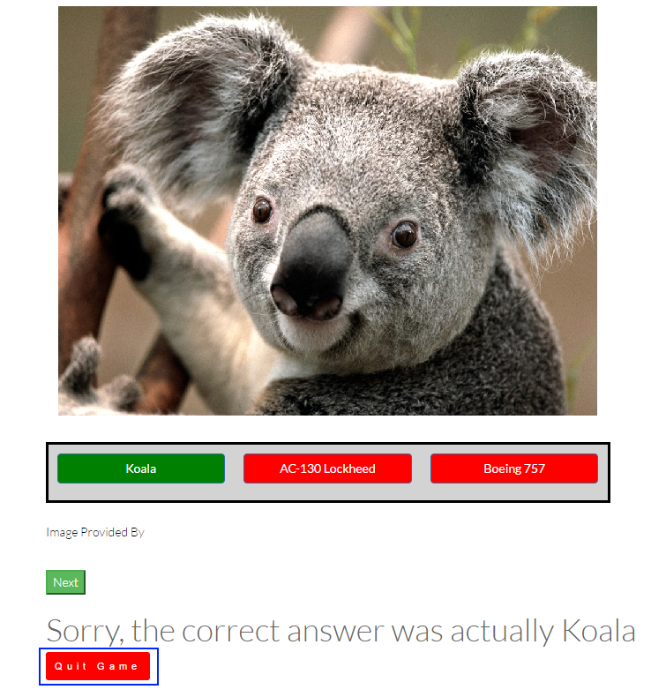

## Game Completion

* Once you either run out of time or answer all the questions for that session, you will be taken to the ‘Game Complete’ screen, where you will see your score, the number of correct answers, and a list of high scores.

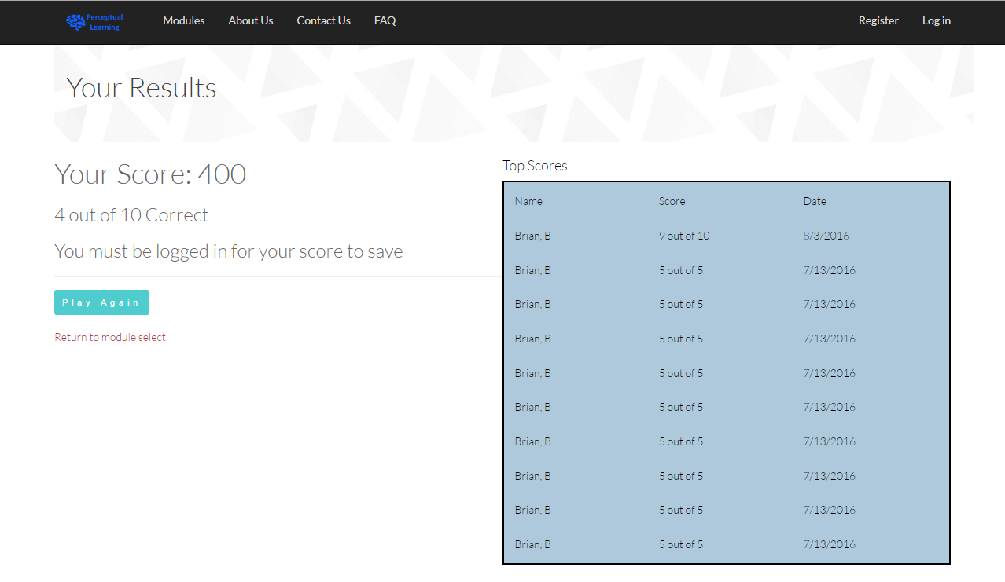

* You can click the “Play Again” button to play the module again, but this will only use the default settings. If you want to use different settings, click the “Return to module select” to go back to the Module Select page. Then follow the steps you just completed.

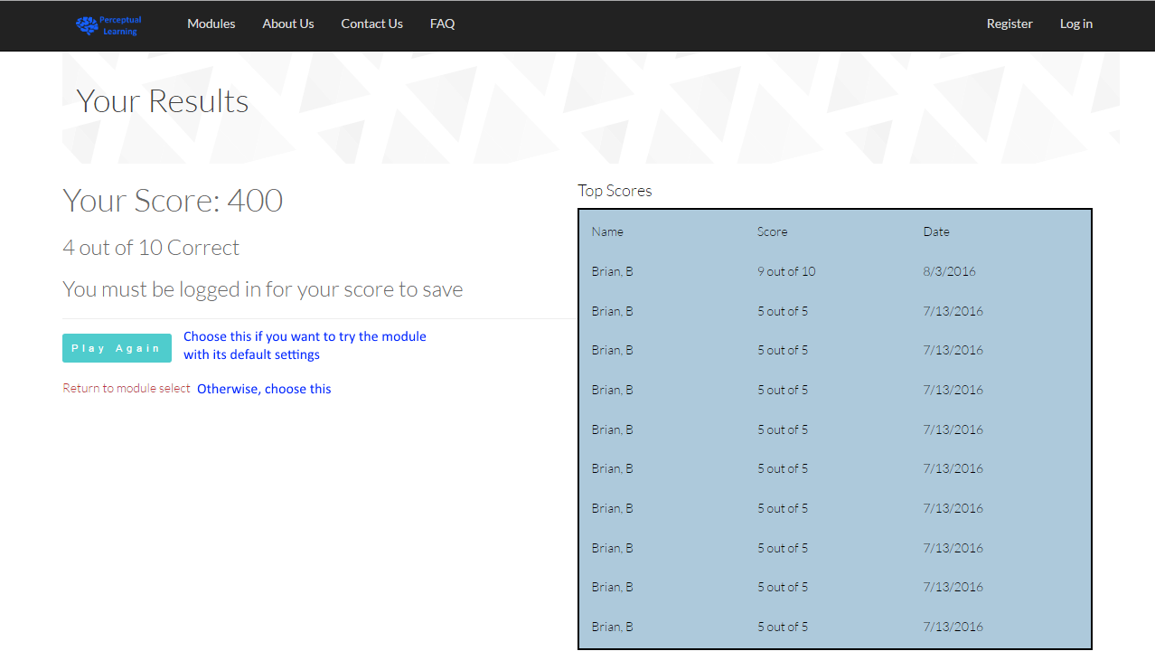

Admininstraion

# Overview

An administrator has the ability to create users, edit user information, enable/disable accounts, change a user’s roles, edit any module, delete any module, disable any module, make reports, and review reports.

You can create a user’s account that they can then use as their own.

Any user registered on this website has their information that can be viewed and edited by an admin. The only reason why this would be important is if the user needed their password changed or if they could no longer access that account.

Any account found that is breaking our Terms of Use or behaving inappropriately on the site can be disabled by an admin so that their account can no longer be logged in. Once an account has been disabled it can be re-enabled if the admin sees fit to do so.

A user’s roles are very important because they unlock different functionality within the site. A user can either be a learner, instructor, admin or any combination of the three. Every user starts off as a learner when their account is created. This role allows a user to play modules and set up a profile. A user may then request to become an instructor and then be approved by the admin. The instructor role will allow a user to create modules. An admin role can only be added to a user by going into that user’s roles as an admin and changing them.

An admin can view all of the modules that have been created by every user. The admin can choose to edit any module as an instructor would. If a module is found to have inappropriate content or is against the terms of use, then the admin can choose to disable that module so that learners can no longer see or play that module.

An admin can view all of the reports that have been made against modules by users. A report is information that a user has commented about a particular module. They may have found inappropriate content or the like that they wish to be reviewed by the instructor that created that module or an admin. The same is true if an admin finds a module which they deem inappropriate.

# User Administration

## Create a User:

* Start at the Administration page.
* 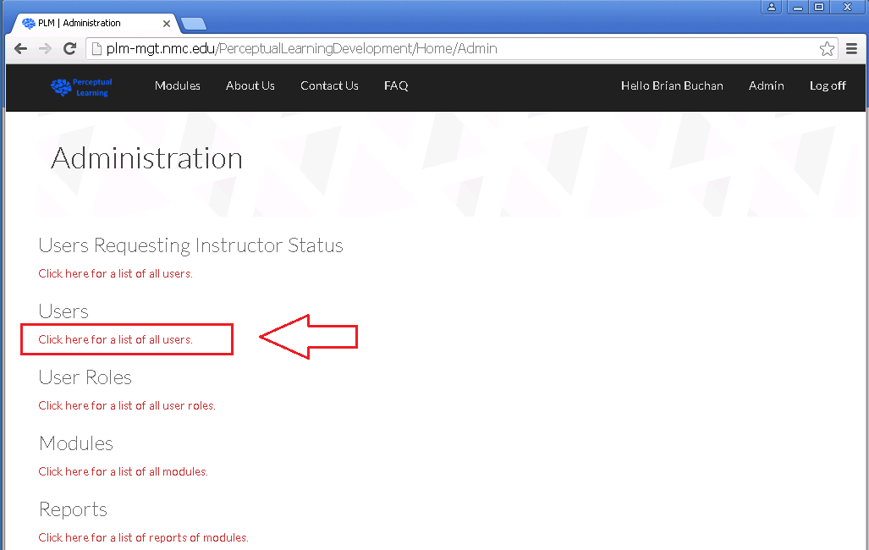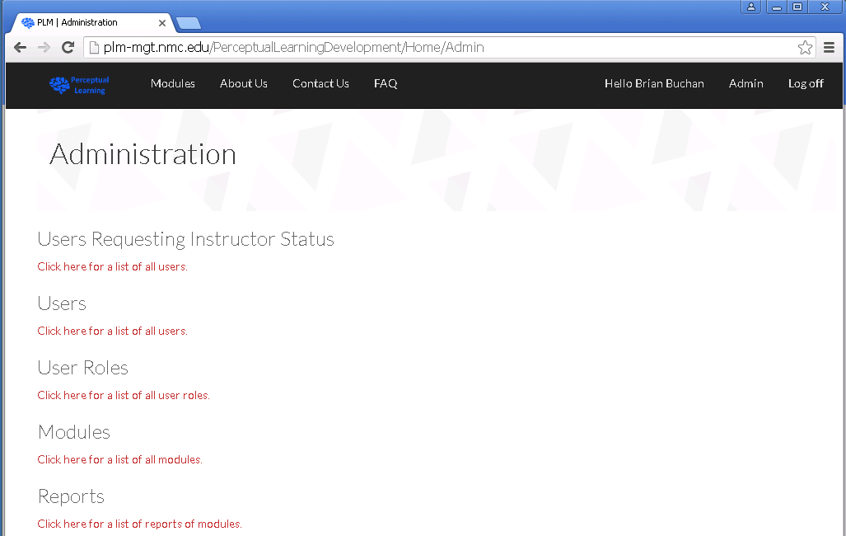Then click the ‘Users’ link.
* You will be navigated to the ‘Users Administration’ page.
* 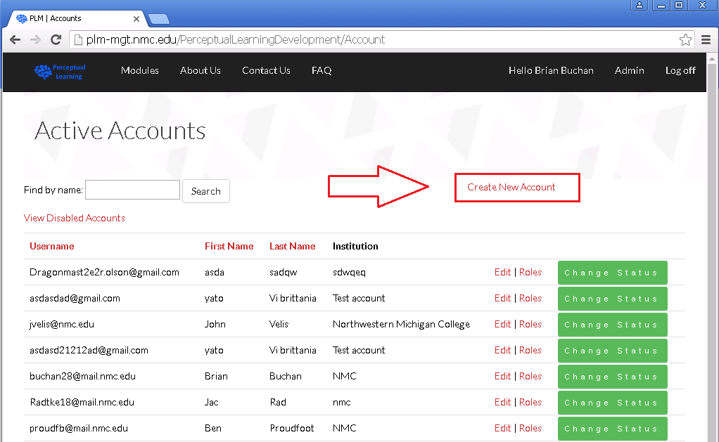Then click the ‘Create New Account’ link.
* 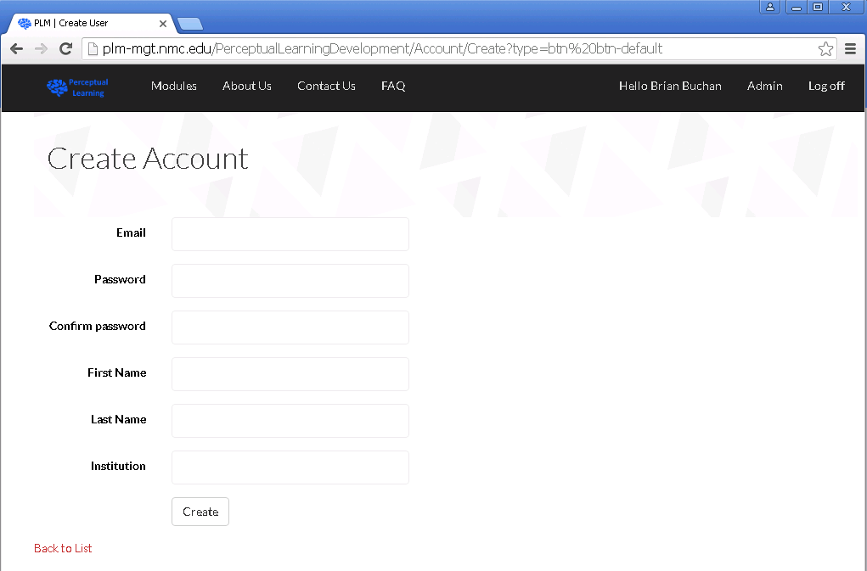You will then be navigated to the ‘Create Account’ page.
* 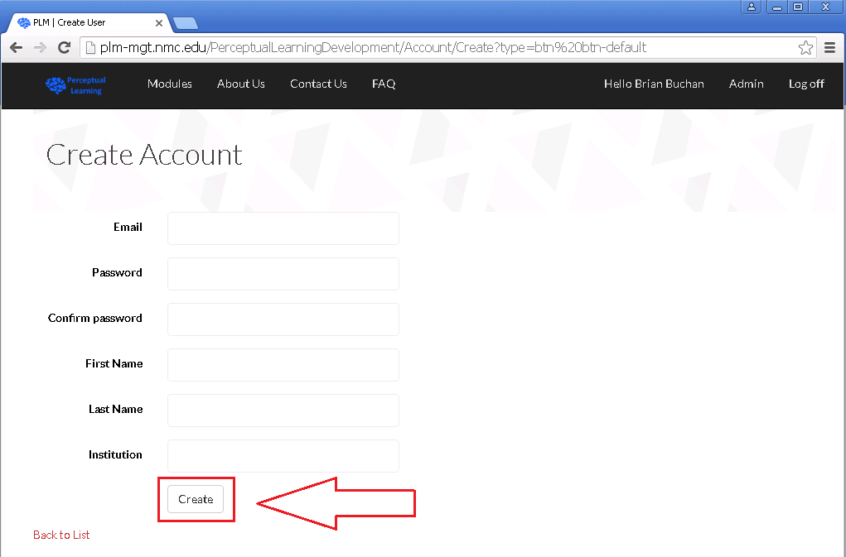Enter in all of the required information and then click the ‘Create’ button to create the account.
* You will then see the new account on the ‘Active Accounts’ page and it will be able to be logged in immediately.

## Edit User Information:

* Navigate to the ‘Administration’ page (see Create a User section).
* Then click on the ‘Users’ link to navigate to the ‘Users’ page (see Create a User section).
* 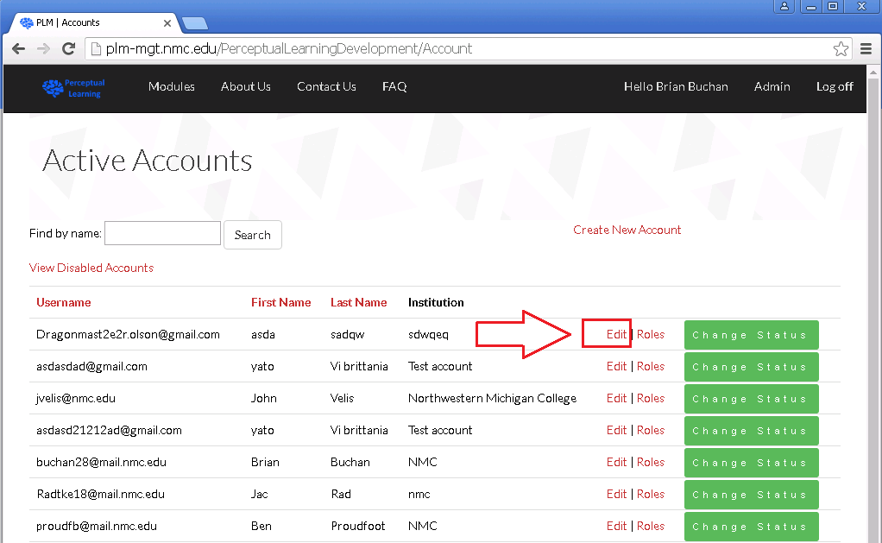Once on the ‘Users’ page, click the ‘Edit’ link by the user that you would like to edit information for.
* If you wish to make any change what so ever you must also change the password for that user. At the given time this is simply how the system works. Generally speaking, you would only need to change a password if a user forgot their previous one.

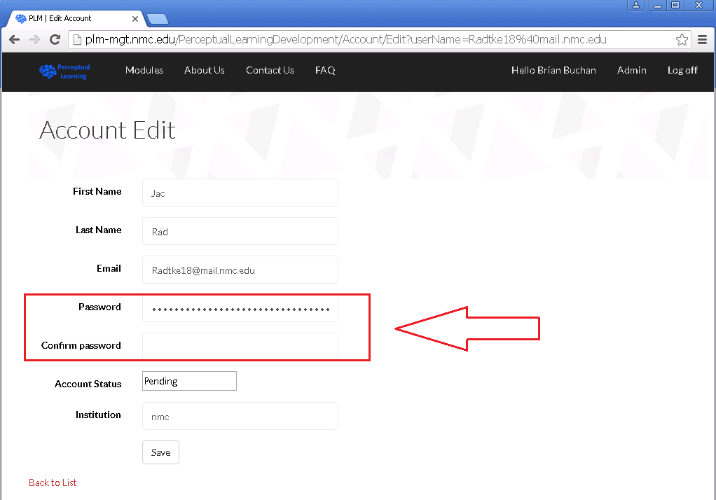

* 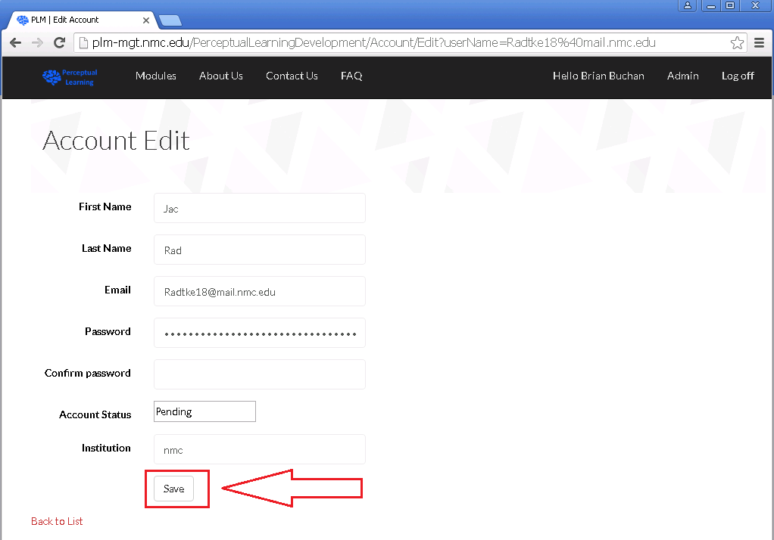Once you have entered a new password and any other required information, click the ‘Save’ button at the bottom of the screen.
* The changes that you have made will now appear on the ‘Users’ page and any other page that references that accounts information.

## Change User Status:

* Navigate to the ‘Administration’ page (see Create a User section).
* Then click on the ‘Users’ link to navigate to the ‘Users’ page (see Create a User section).
* 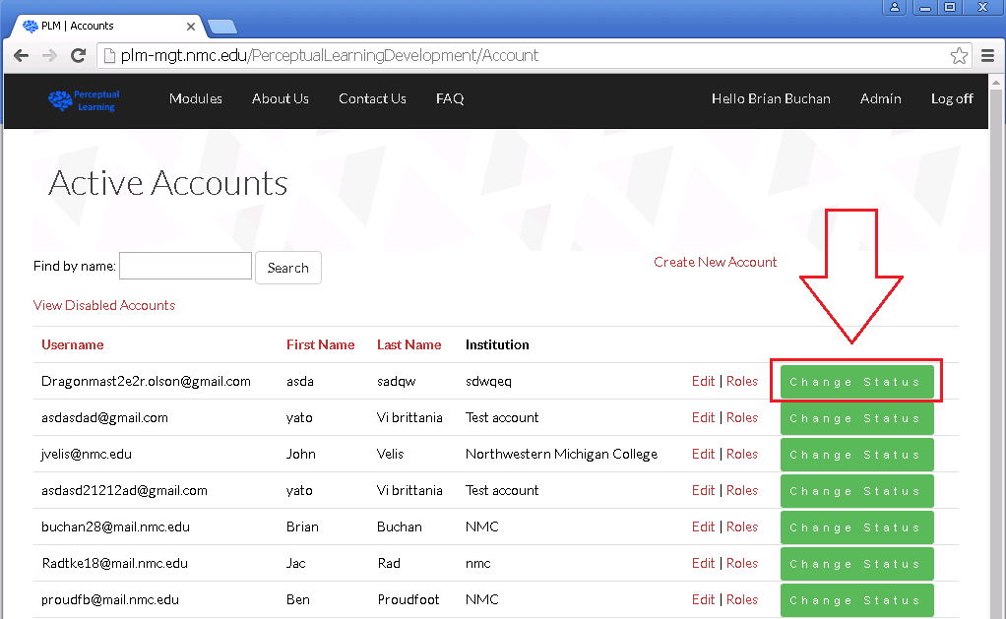Once on the ‘Users’ page, click the ‘Change Status’ button for the user that you wish to modify their status.
* You will then be navigated to the ‘Change Status’ page for that user.
* 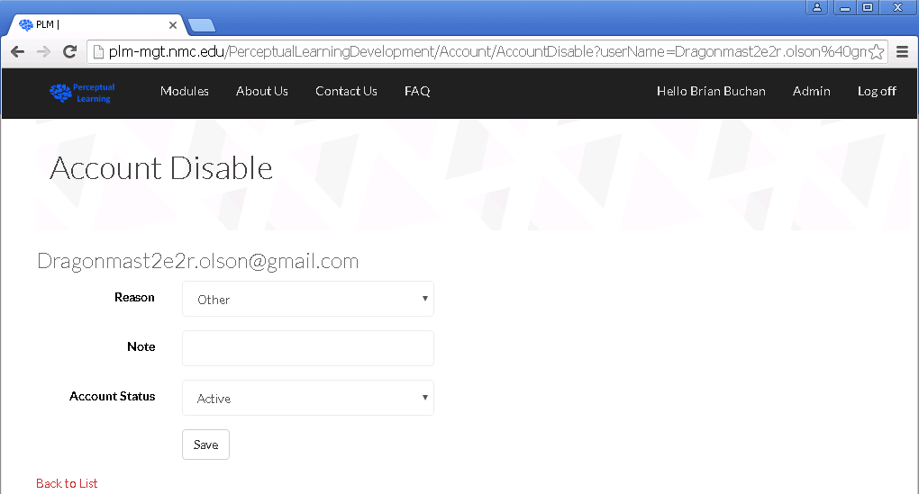Once on the ‘Change Status’ page, you may enter a reason for the status change from a dropdown menu. Possible reasons to change the status of a user may be that you wish to disable a user for inappropriate behavior. You may leave a note as to leave more detailed, open-ended information for the change.
* The most important part is the ‘Account Status’ dropdown menu. You may select pending, pending instructor role, active, or disabled. Pending is for accounts that are new and do not yet have a confirmed email address. Pending instructor role is for users that wish to be in the role of instructor so that they can create modules but have yet to be approved by an administrator. The active role is for users that have a general active account that can play modules etc. Disabled accounts are for accounts that we wish to no longer have access to the site and cannot be logged in.
* 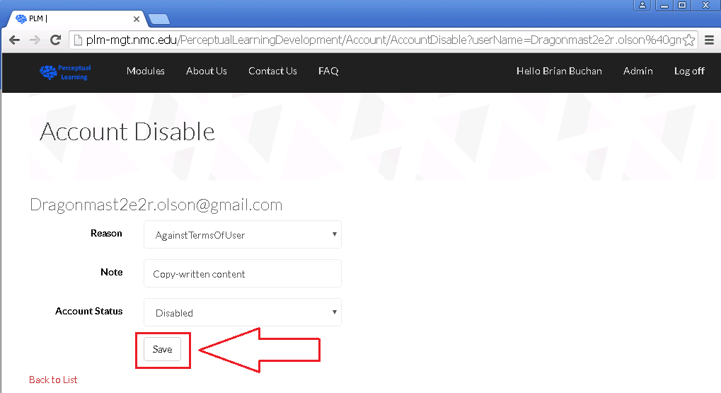Once you have made any desired changes to a user’s status you may click the save button at the bottom of the screen.
* If a user is disabled then the effect would be effective immediately.
* 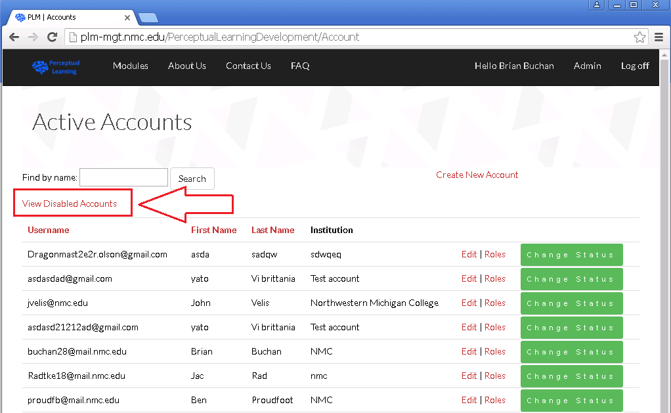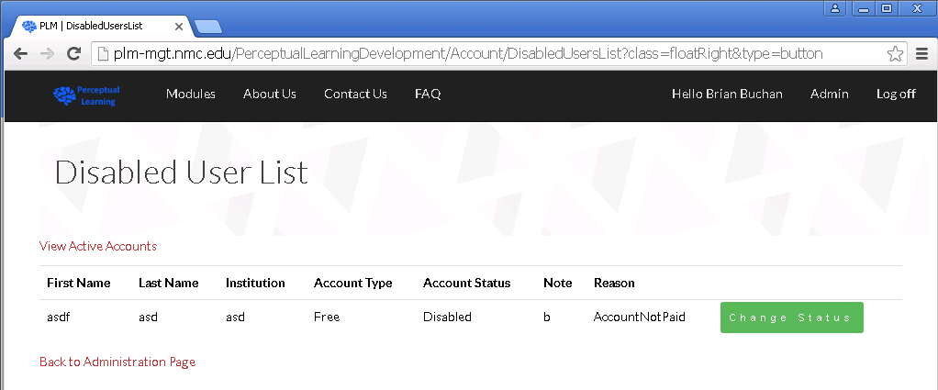If you choose to you may re-enable a user you may go to the ‘Disabled Users’ page by clicking on the ‘View Disabled Accounts’ link on the ‘Users’ page.
* You will then be navigated to the ‘Disabled User List’ page.
* Use the method described above to disable a user to re-enable that user. First click the ‘Change Status’ button. Then, the only difference is that you simply change the ‘Account Status’ dropdown from Disabled to Active and click the ‘Save’ button.

# User Instructor Requests

## Accept:

* Navigate to the ‘Administration’ page (see Create a User section).
* 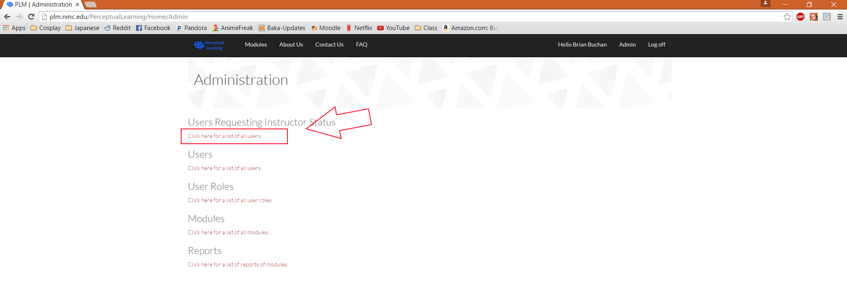Then click on the ‘Users Requesting Instructor Status’ link to navigate to the ‘User Requests’ page.
* 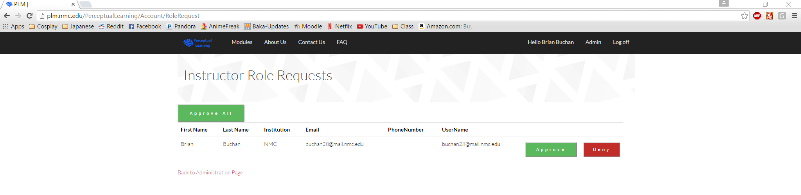You will be navigated to the ‘Role Request’ page.
* To accept a user’s request, click the ‘Approve’ button beside their name.
* Once you click the ‘Accept’ button for a user their request will be removed from the ‘Role Requests’ page and that user will then be able to create modules.
* 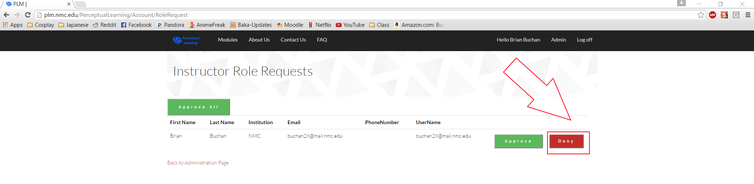To deny a user’s request to become an instructor, click the ‘Deny’ button beside their name.
* Once you click the ‘Deny’ button for a user their request will be removed from the ‘Role Requests’ page and that user will continue to be a regular user but will NOT be able to create modules.
* 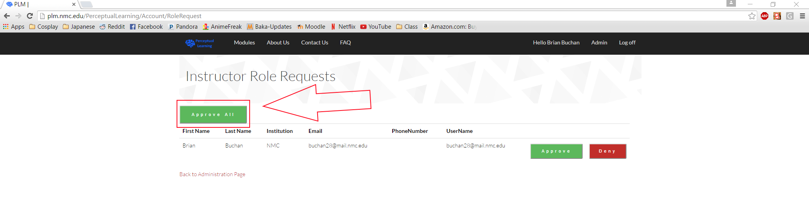If you wish to approve all users on the ‘Role Requests’ page at once, you may click the ‘Approve All’ button at the top of the page. 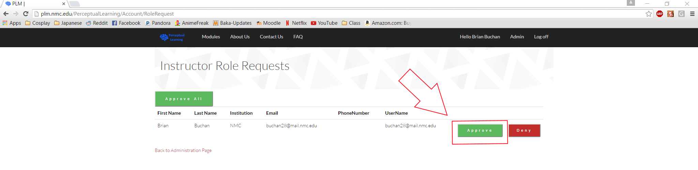
* Once the ‘Approve All’ button is pressed then all of the users will then be able to create modules as an instructor. The page will then refresh with no users in the list. Make sure to deny any users that you do not wish to be instructors before pressing this button.

# Roles

## Add a Role to a User:

* Navigate to the ‘Administration’ page (see Create a User section).
* Then click on the ‘Users’ link to navigate to the ‘Users’ page (see Create a User section).
* 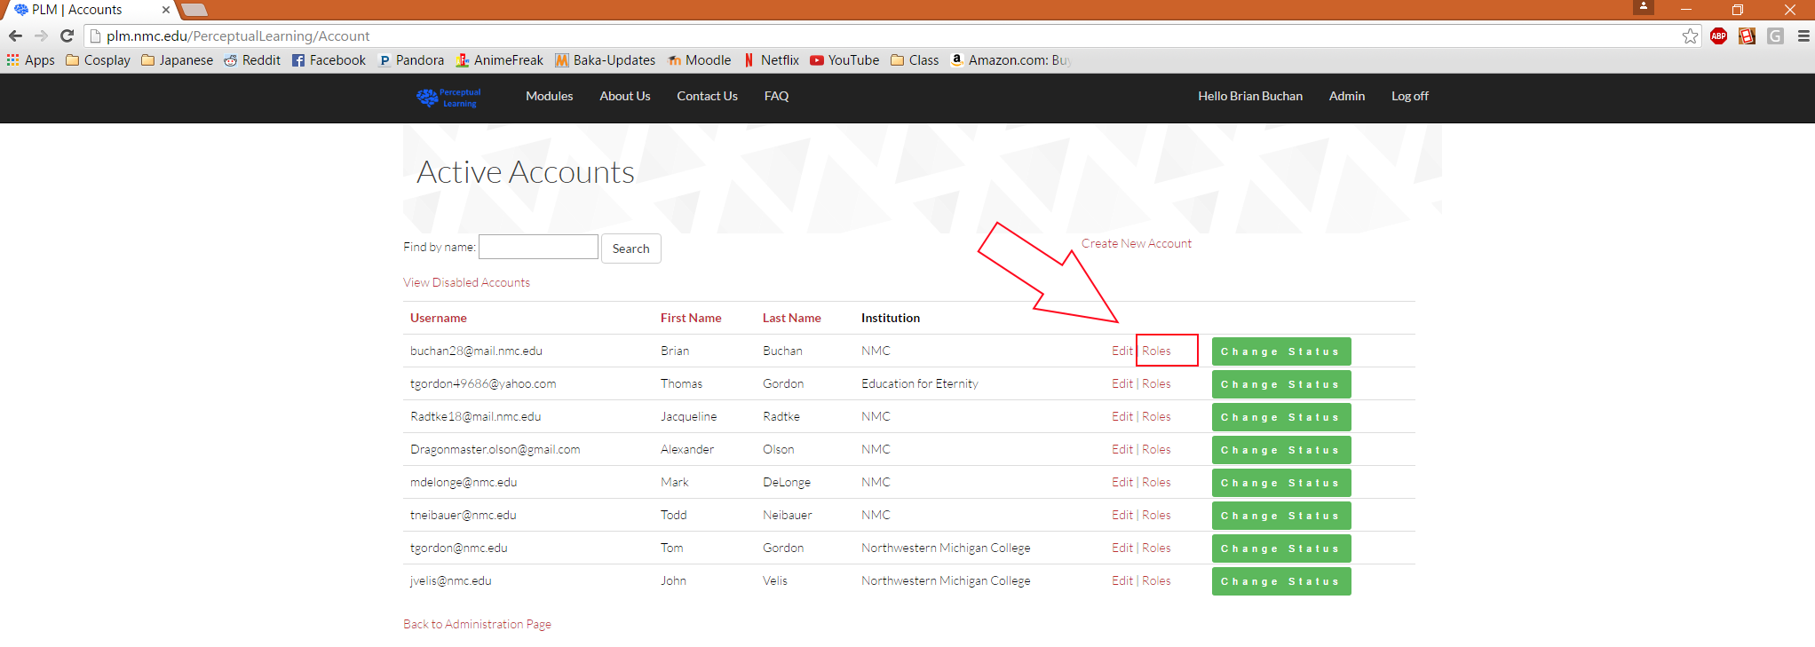Once on the ‘Users’ page, you may change the roles assigned to a user by clicking the ‘Roles’ link next to their name.
* 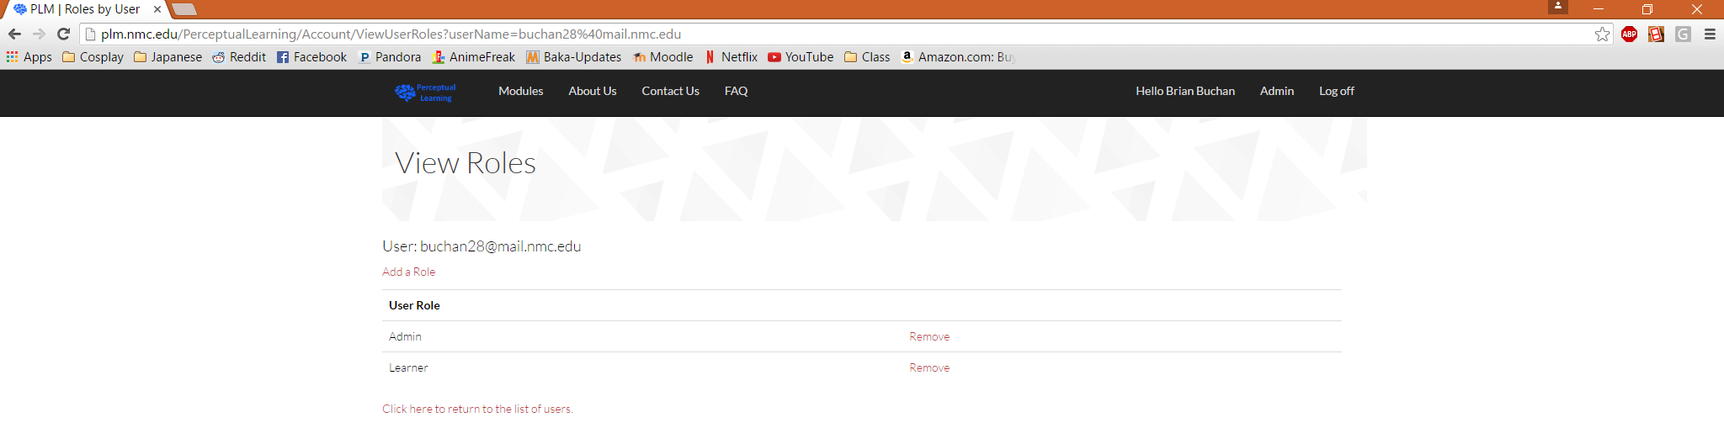You will then be navigated to ‘View Roles’ page for that user.
* 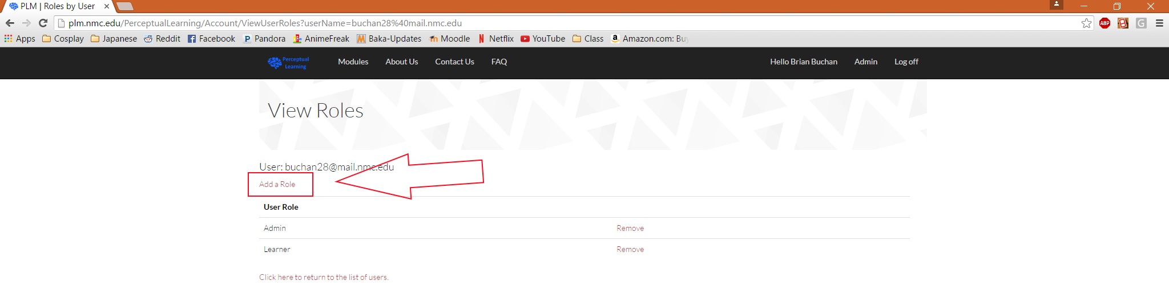To add a role to that user, you must click the ‘Add a Role’ link above the list of user roles.
* 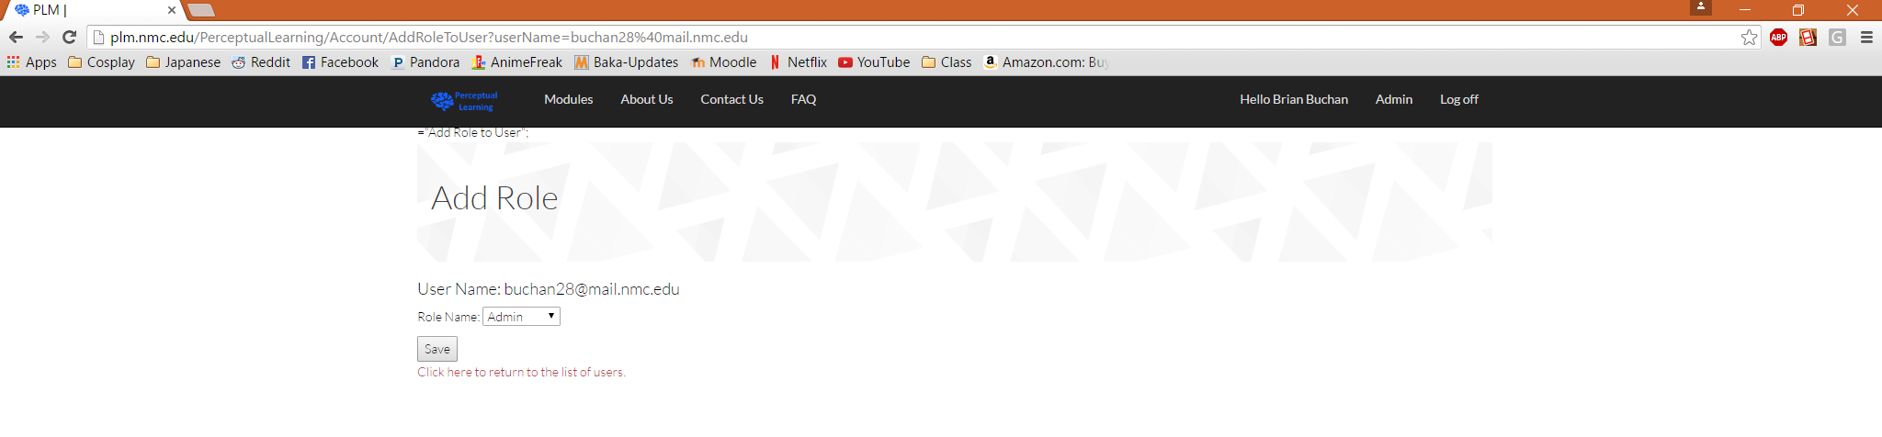You will be navigated to the ‘Add a Role’ page.
* 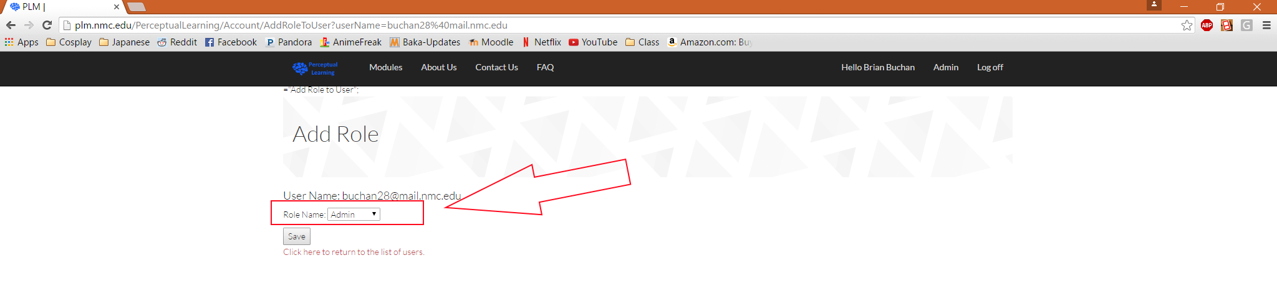To add a role simply select the role that you would like to add from the dropdown menu.
* Then click the ‘Save’ button to finalize your decision.
* You will then be navigated back to the ‘View Roles’ page for that user. This page should have been updated with the new role that you just added.

## Remove a Role from a User:

* Navigate to the ‘Administration’ page (see Create a User section).
* Then click on the ‘Users’ link to navigate to the ‘Users’ page (see Create a User section).
* Once on the ‘Users’ page, you may change the roles assigned to a user by clicking the ‘Roles’ link next to their name (see Add a Role section).
* You will then be navigated to ‘View Roles’ page for that user (see Add a Role section).
* 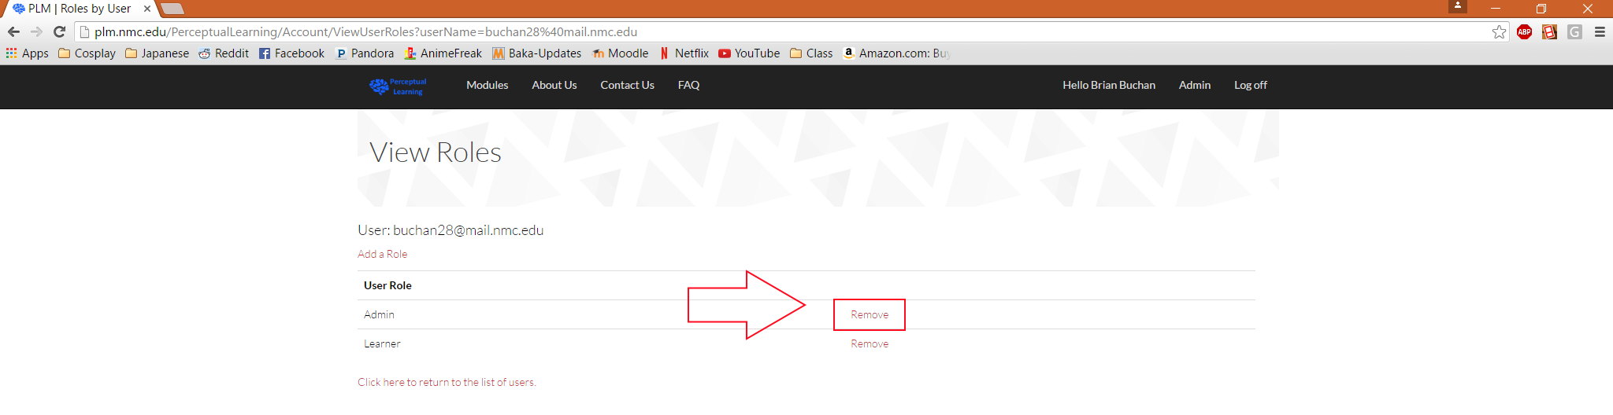Then you must click the ‘Remove’ link next the role that you wish for a user to no longer have.
* Once you click the ‘Remove’ button the page will refresh without that role in that user’s role list. The user will no longer be able to complete actions that require membership to that role.

## Change Roles:

* Navigate to the ‘Administration’ page (see Create a User section).
* 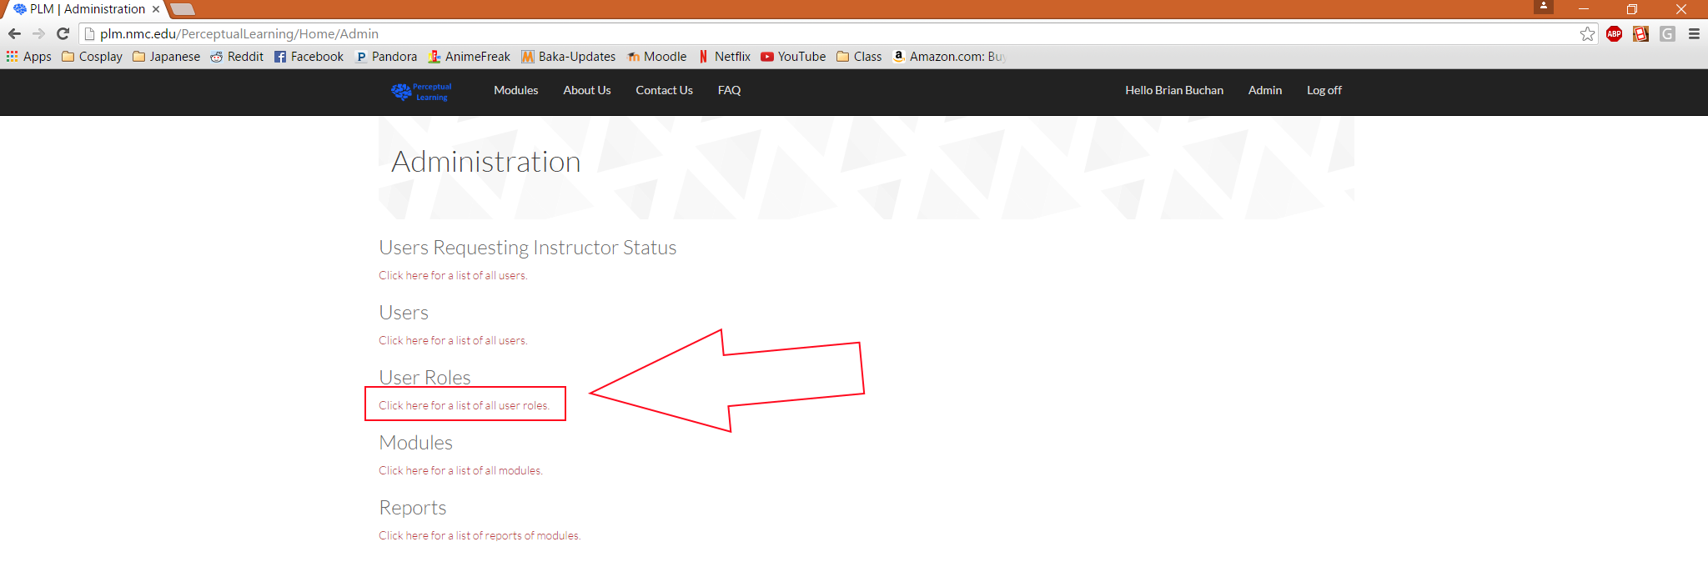Then click on the ‘User Roles’ link to navigate to the ‘User Roles’ page.
* 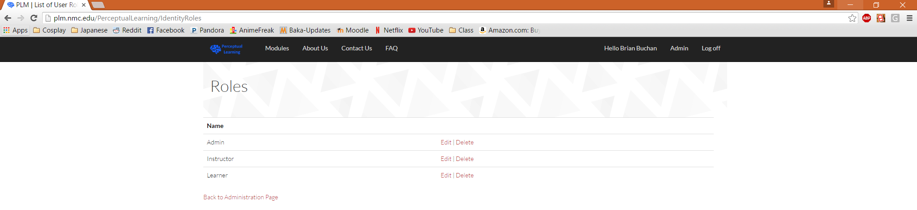You will be navigated to the ‘Roles’ page.
* 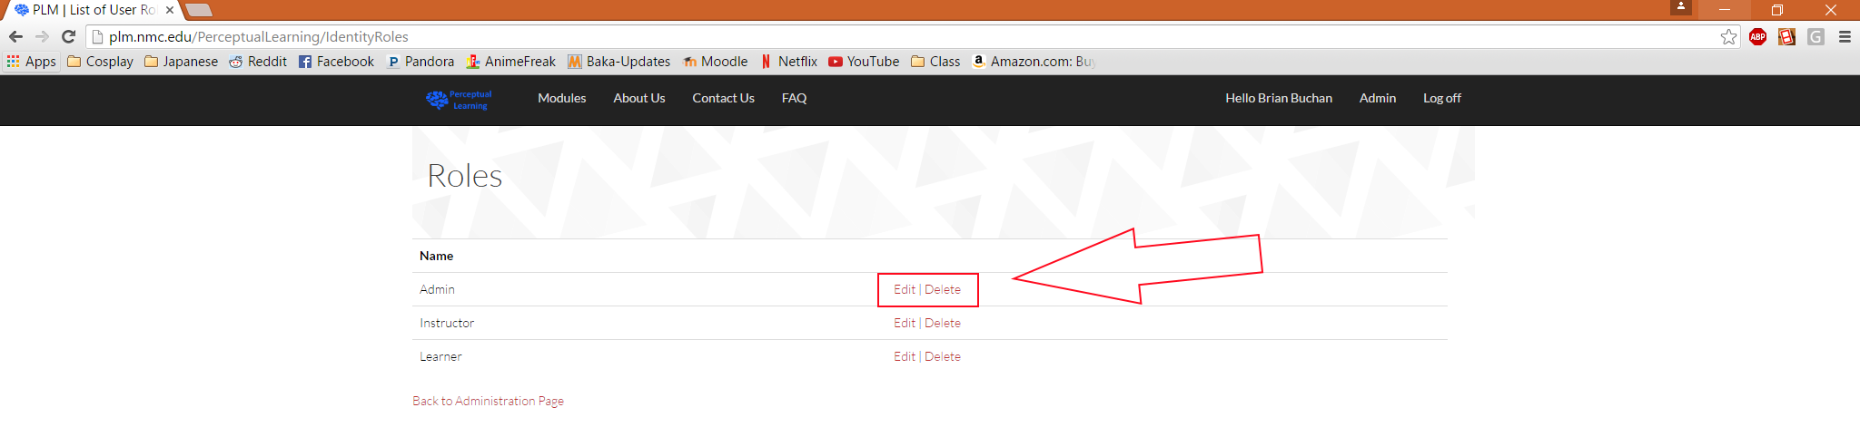You will see ‘Edit’ and ‘Delete’ links beside each role.
* Unless you are doing an entire overhaul of the site, NEVER use these buttons. If you edit a role or delete a role, then all permissions associated with that role will be broken. This will happen if the spelling of the role is changed as well.
* 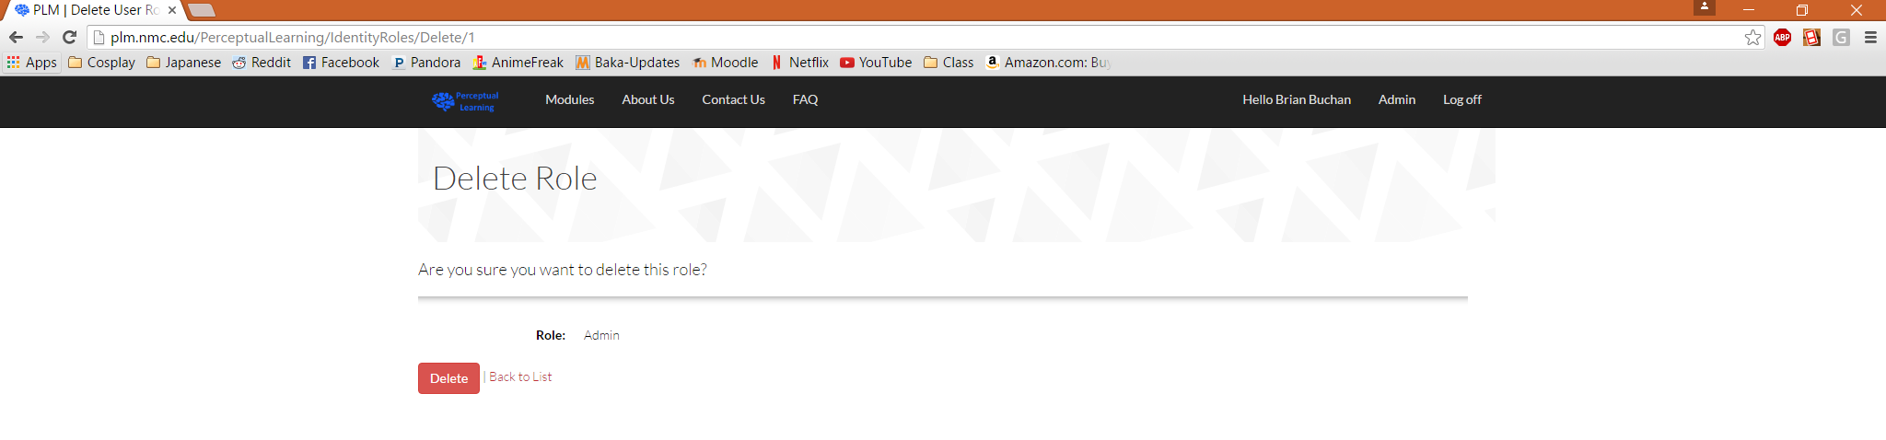If you click on the ‘Delete’ link, then you will be navigated to the ‘Delete Confirm’ page that will ask if you are sure if you would like to delete that role.
* If you click the ‘Delete’ button, you will navigate back to the list of available roles on the ‘Roles’ page, and you will have likely broken the website.
* 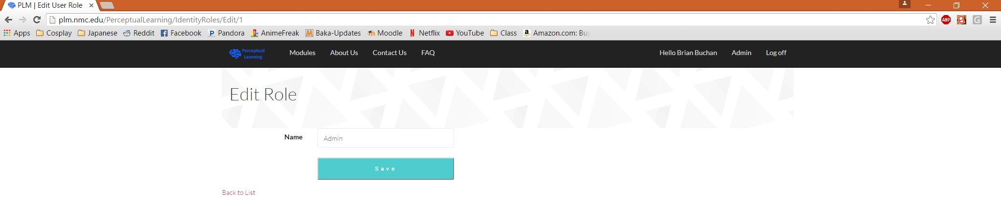If you click the ‘Edit’ button on the ‘Roles’ page, then you will navigate to the ‘Edit Role’ page.
* On the ‘Edit Role’ page, you can change the text in the textbox and then click the ‘Save’ button to edit the role, and you will have likely broken the website.
* Once you click the ‘Save’ button, you will navigate back to the ‘Roles’ page with the updated role in the list of roles.

# Modules

## Edit:

* Navigate to the ‘Administration’ page (see Create a User section).
* 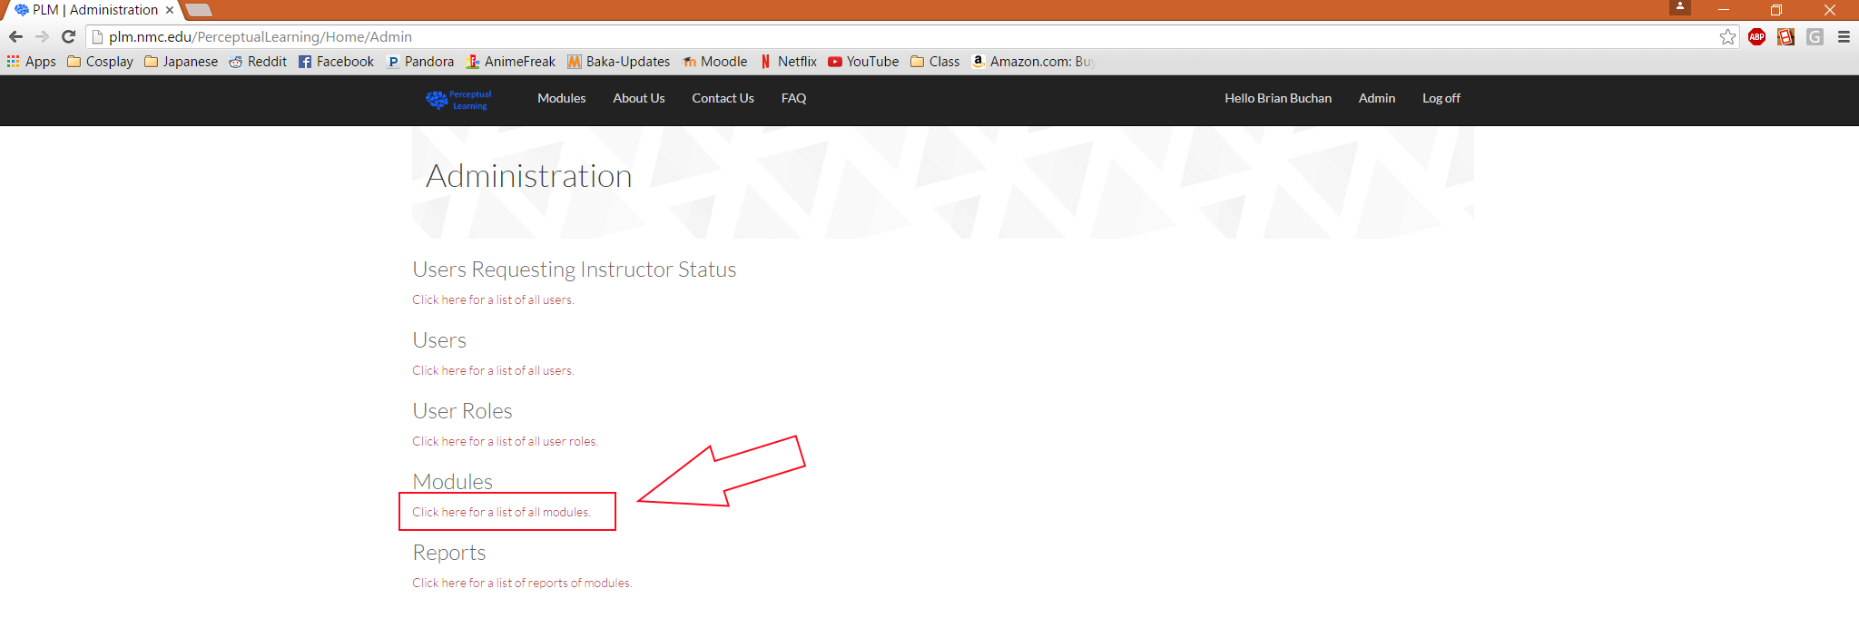Then click on the ‘Modules’ link to navigate to the ‘Modules’ page.
* 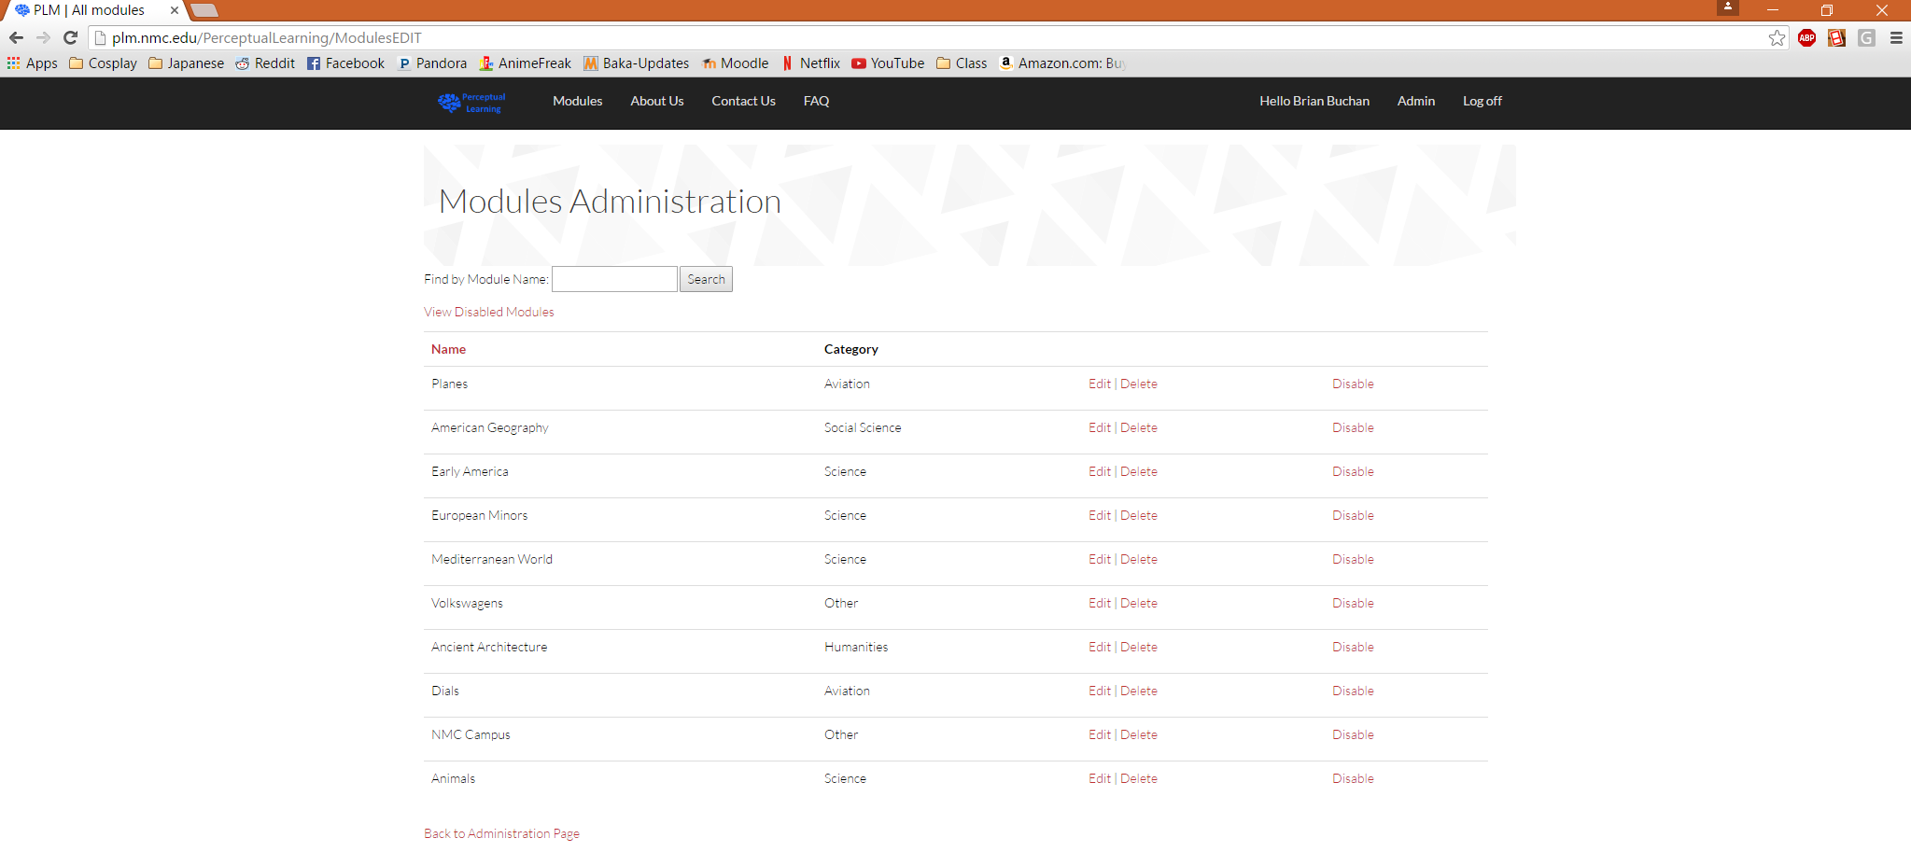Then you will be navigated to the ‘Modules Administration’ page.
* To edit a module, click the ‘Edit’ link beside the module that you wish to edit.
* 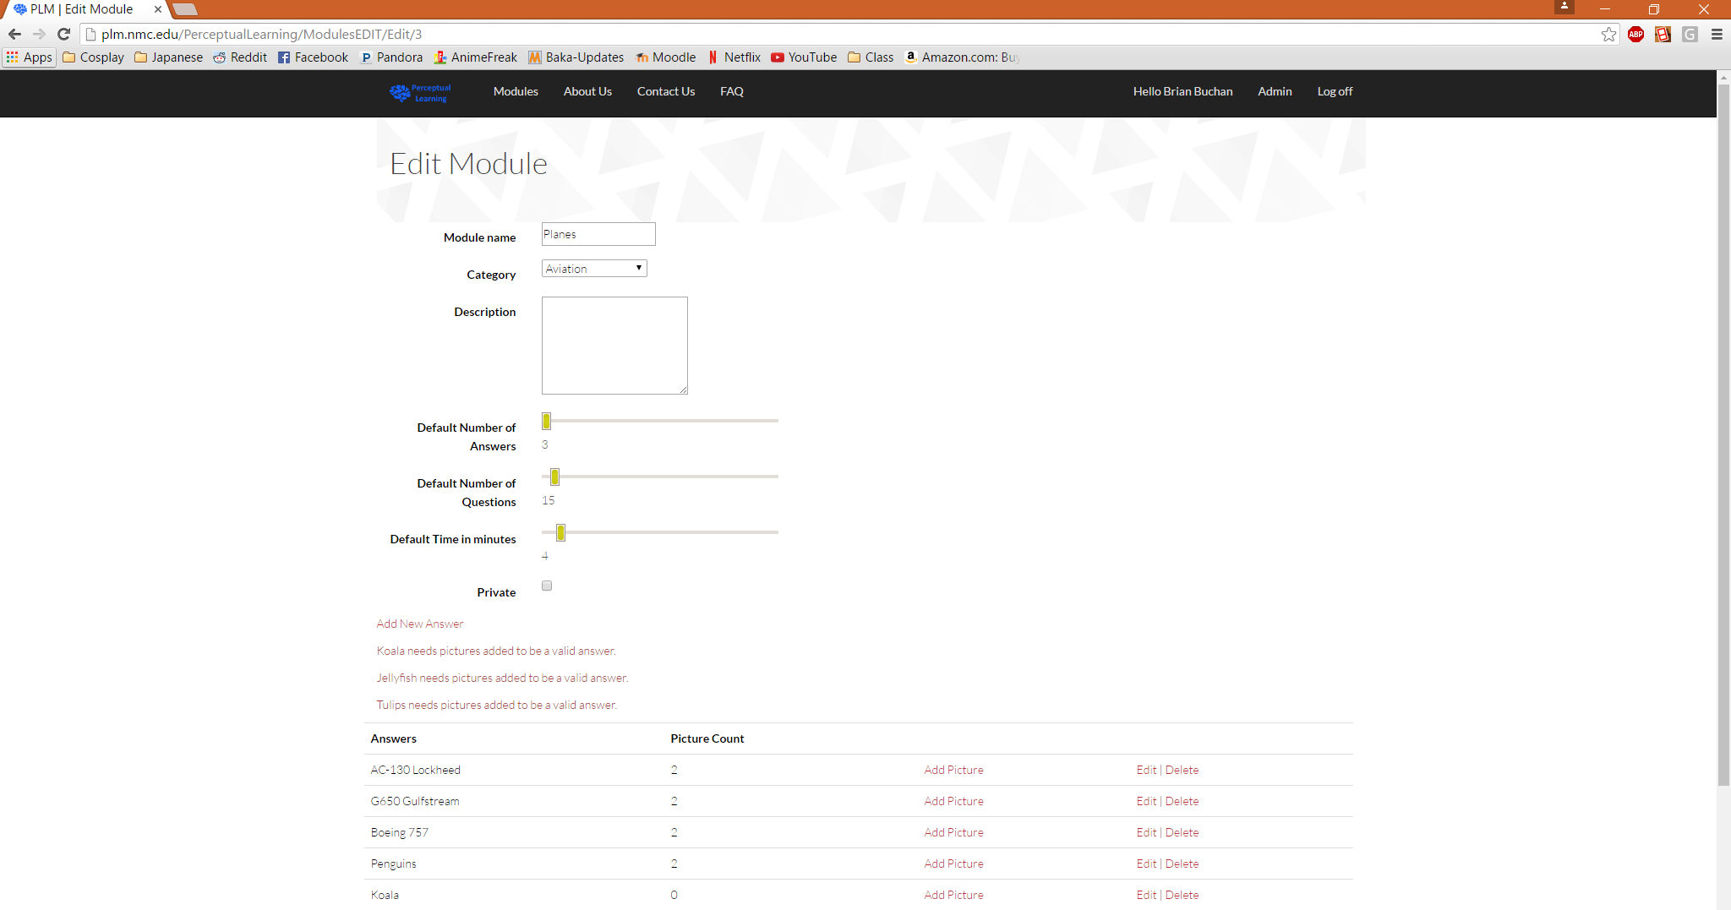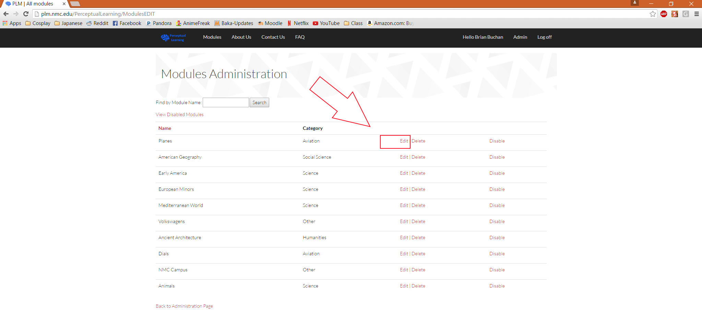Then you will be navigated to the ‘Module Edit’ page. This page will appear as it normally would if you were the instructor that created the selected module.
* From this screen, you can edit any of the fields or follow links to add answers, add pictures, edit answers, or delete answers for the selected module as you would as an instructor.
* For more information, see the section on module creation.
* 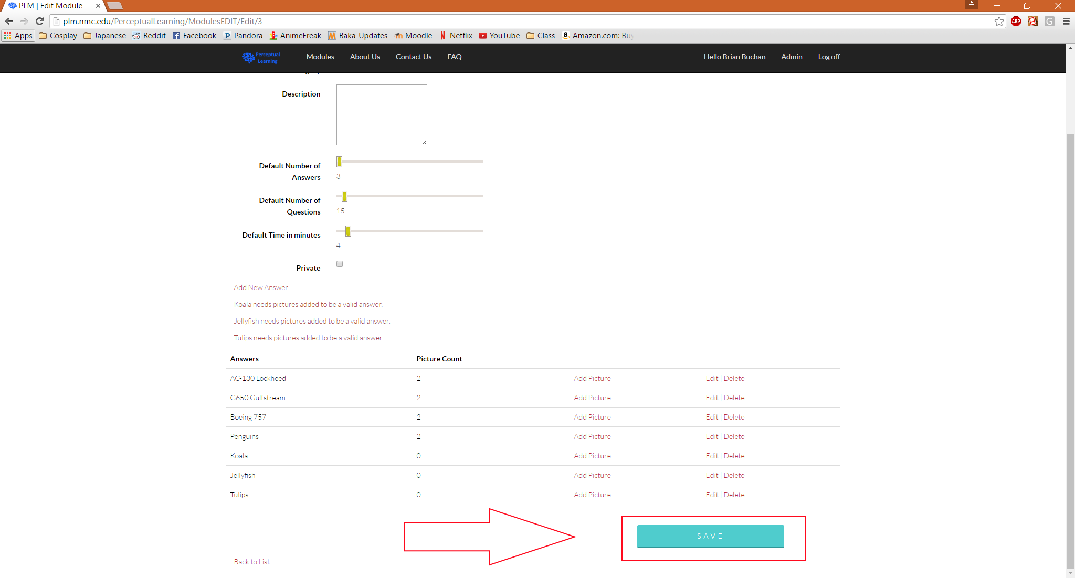Once you are satisfied with any changes, scroll to the bottom of the ‘Edit Module’ page and click the ‘Save’ button to finalize your decision.

## Disable/Enable:

* Navigate to the ‘Administration’ page (see Create a User section).
* 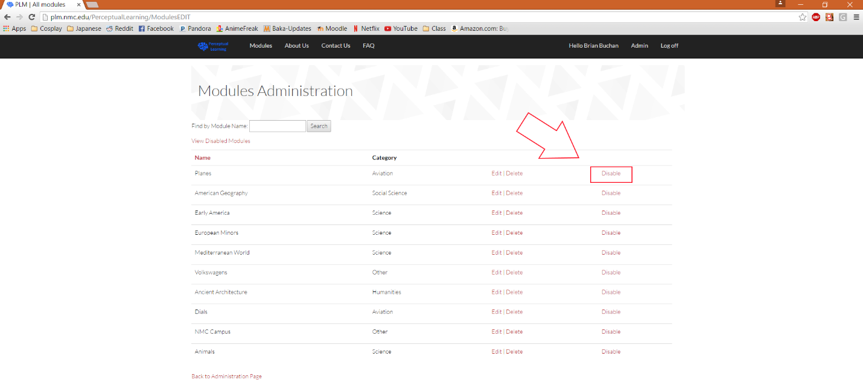Then click on the ‘Modules’ link to navigate to the ‘Modules’ page (see Edit a Module section).
* To disable a module so that a user can no longer play that module, you must click the ‘Disable’ link beside the name of the module that you wish to disable.
* 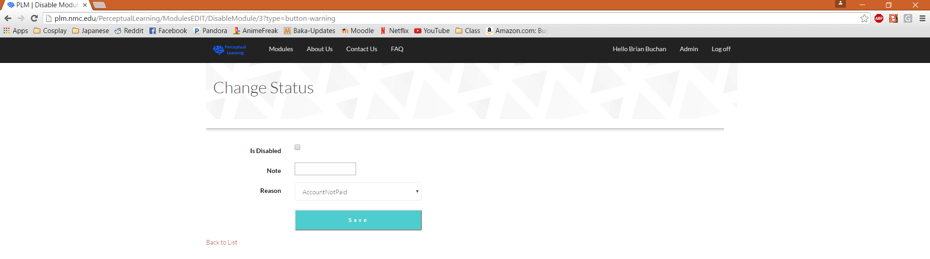Then you will navigate to ‘Change Status’ page for that module.
* If you check the ‘Is Disabled’ checkbox, then the module will be disabled.
* As well, you can leave a note in the ‘Note’ textbox as to why the decision was made to disable the module if additional information is needed.
* 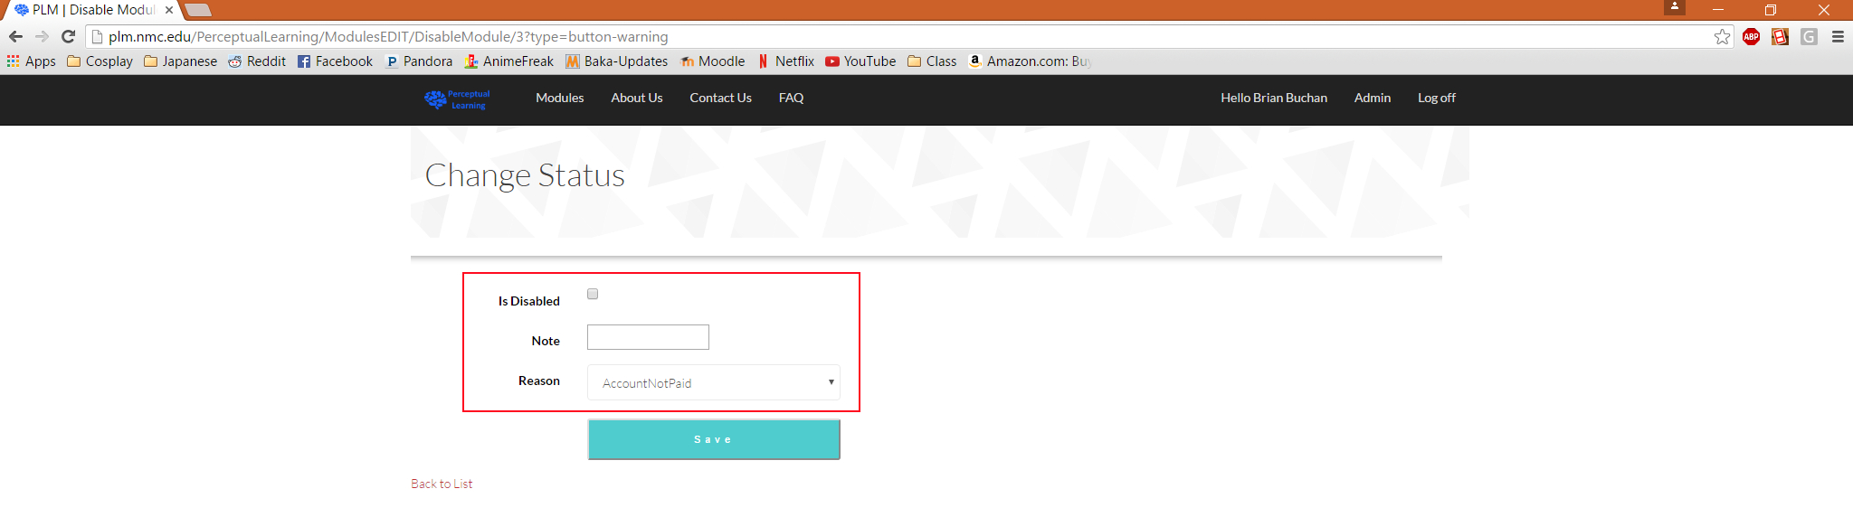You can select a reason from the ‘Reason’ dropdown menu to select a simple reason as to why a module is disabled.
* 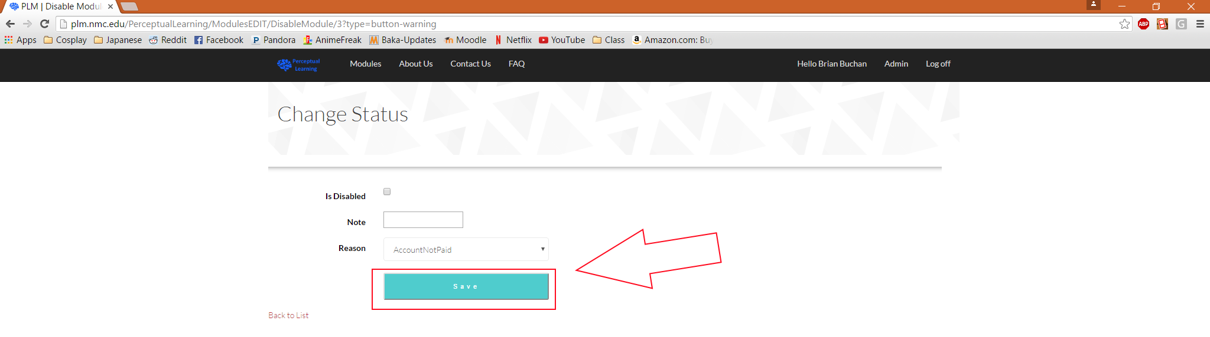Once you are satisfied with your selections, you must click the ‘Save’ button to finalize your choices.
* Then you will be navigated back to the ‘Modules Administration’ page.
* 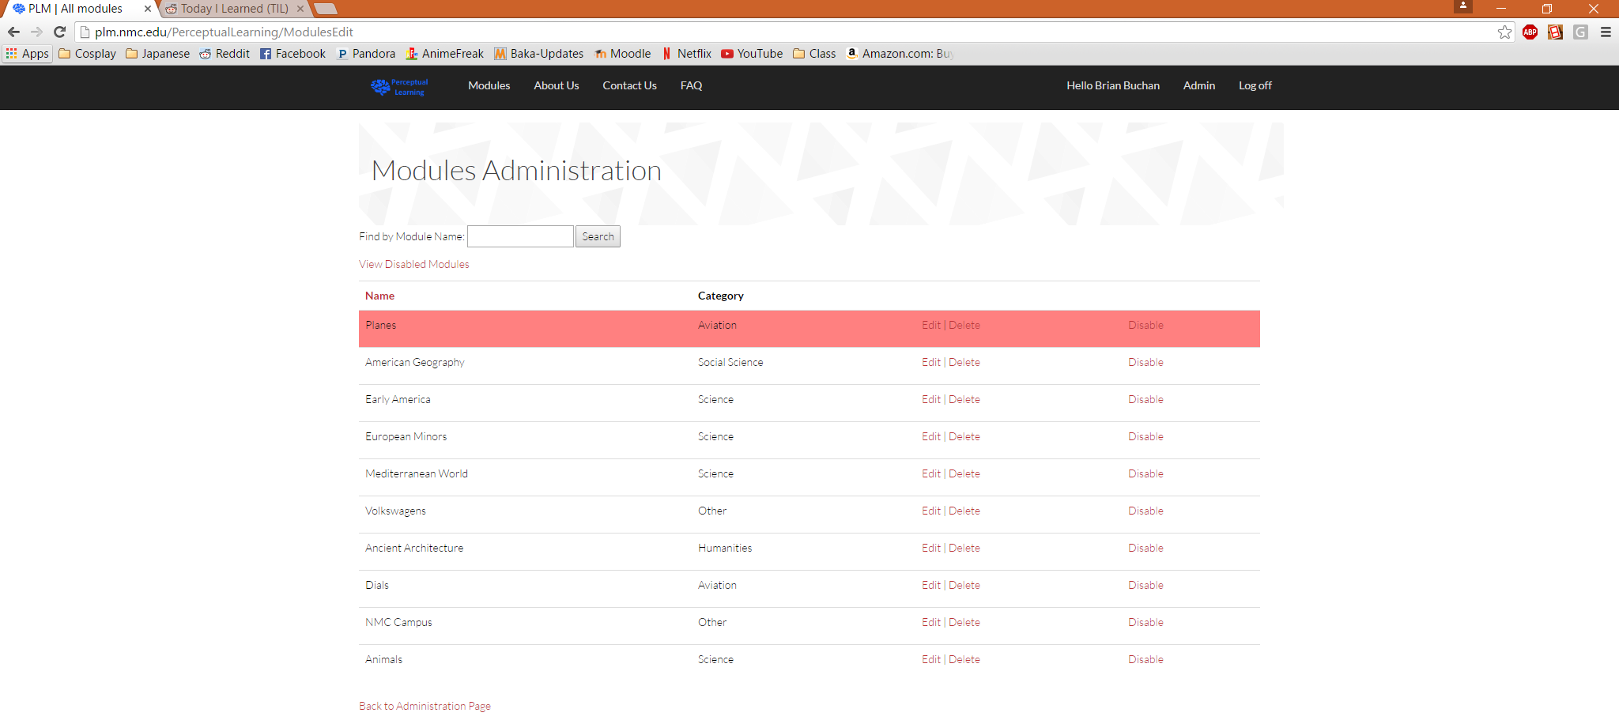You will notice that the module that was just disabled will still appear on the ‘Modules Administration’ page; however, it will now have a red background to the listing.
* You may re-enable the module by clicking the ‘Disable’ link again and follow the same process as the above steps only make sure that the ‘Is Disabled’ checkbox is unchecked. The module will then be available to be played and will appear with a with background once again.

## Delete:

* Navigate to the ‘Administration’ page (see Create a User section).
* 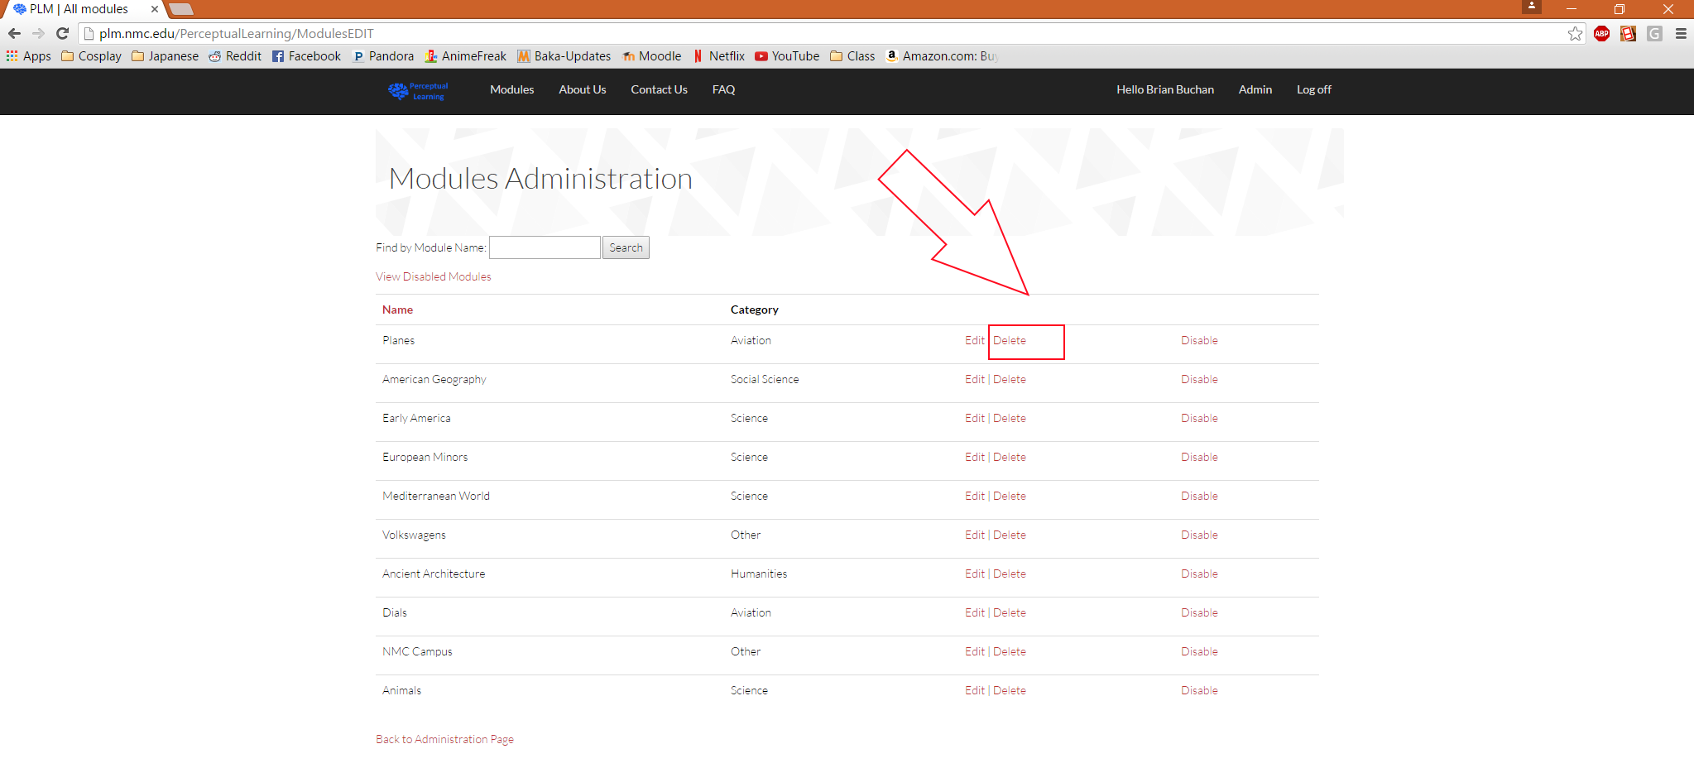Then click on the ‘Modules’ link to navigate to the ‘Modules’ page (see Edit a Module section).
* To delete a module, click on the ‘Delete’ link next to the module that you wish to delete.
* 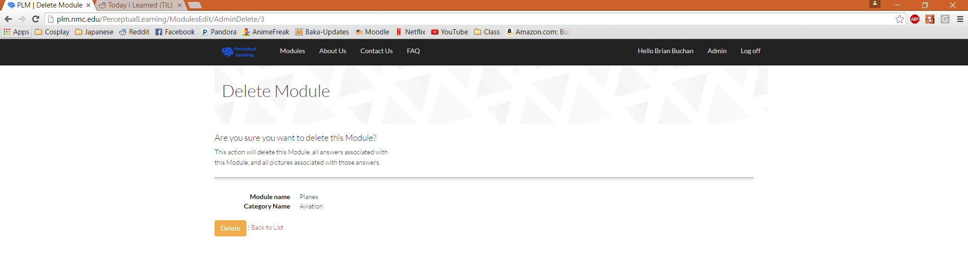You will then be navigated to a ‘Delete Module’ page for the selected module.
* 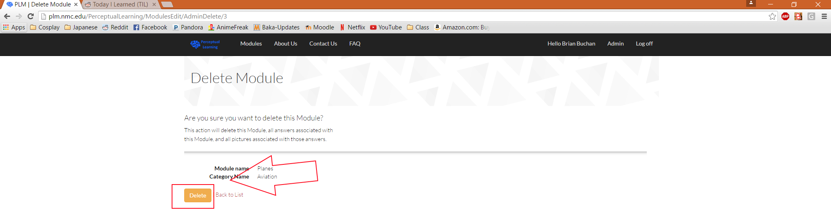If you are sure that you would like to delete the module, then you may click the ‘Delete’ button to finalize your decision.
* Once you have clicked the ‘Delete’ button, you will be navigated back to the ‘Modules Administration’ page.

# Reports

* Navigate to the ‘Administration’ page (see Create a User section).
* 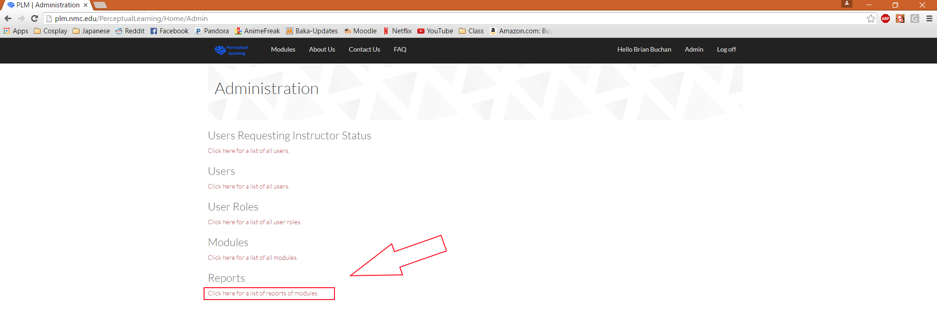Then click on the ‘Reports’ link to navigate to the ‘Reports Administration’ page.
* 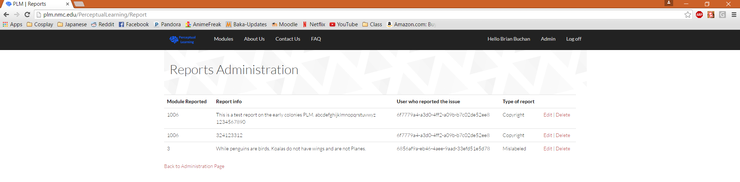Then you will be navigated to the ‘Reports Administration’ page.
* To edit a report, click the ‘Edit’ link besides the report that you would like to edit.
* 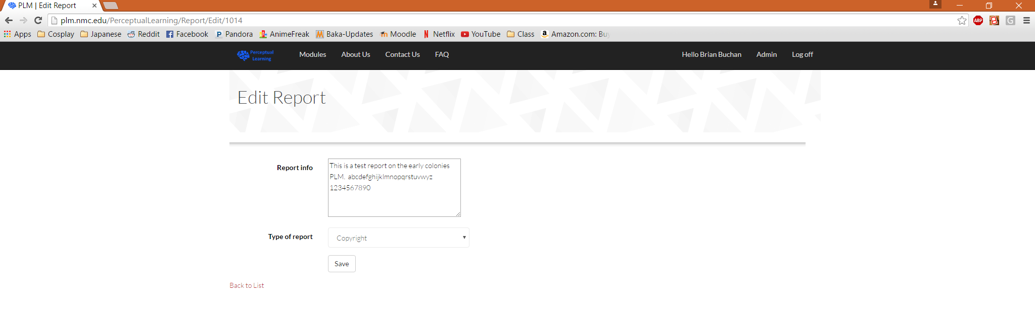Then you will be navigated to the ‘Edit Report’ page for the selected report.
* You can edit the report information by changing the text in the ‘Report Info’ text box.
* 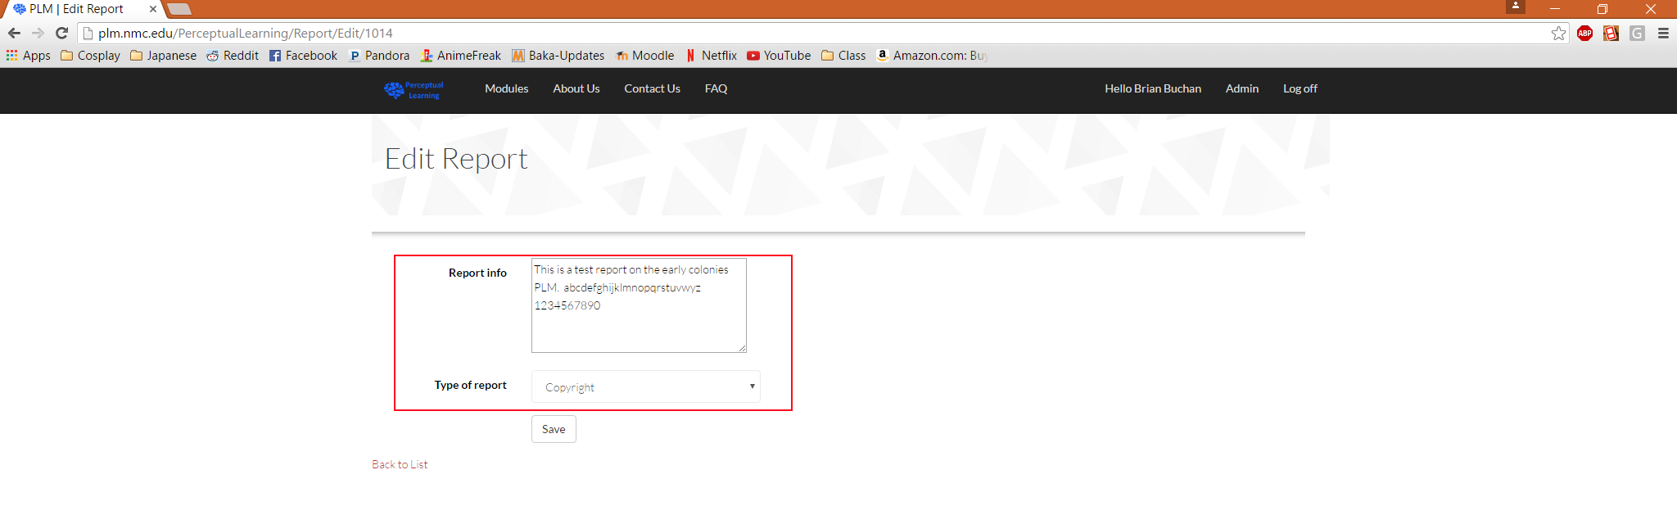You can also change the type of report by selecting the desired option from the ‘Type of Report’ dropdown menu.
* 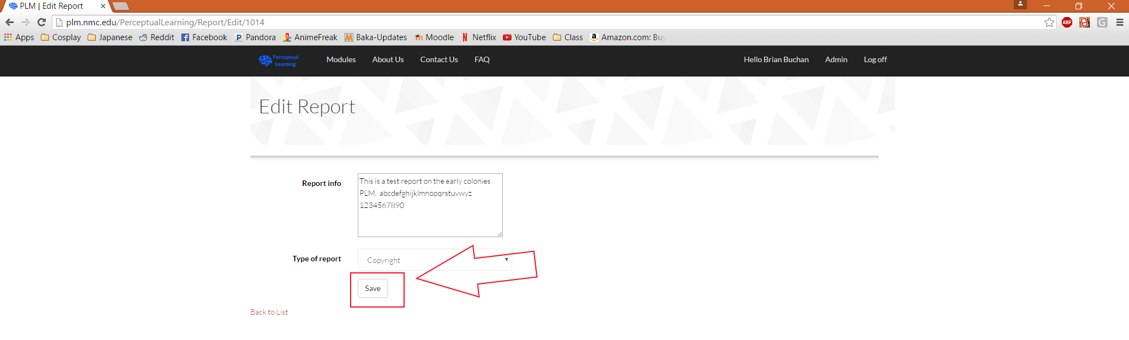Once you are stratified with the changes that you have made to the report you may click the ‘Save’ button to finalize your decision.
* Once you click the ‘Save’ button you will be navigated back to the ‘Reports Administration’ page where you will see the updated report information.

### Delete a Report:

* Navigate to the ‘Administration’ page (see Create a User section).
* Then click on the ‘Reports’ link to navigate to the ‘Reports Administration’ page (see Edit a Report section).
* Then you will be navigated to the ‘Reports Administration’ page (see Edit a Report section).
* 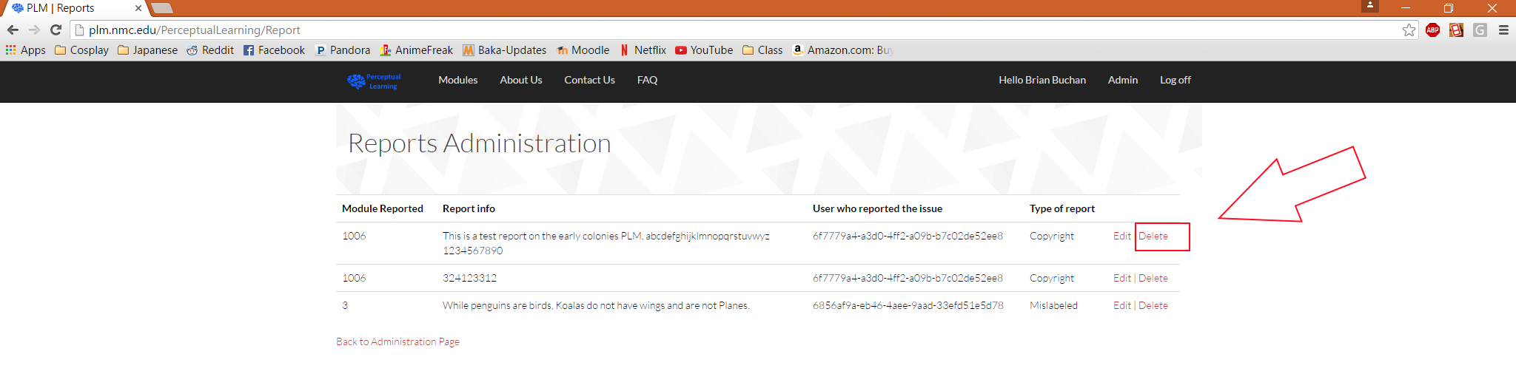To delete a report, click the ‘Delete’ link besides the report that you wish to delete.
* Then you will be navigated to the ‘Delete Report’ page.
* 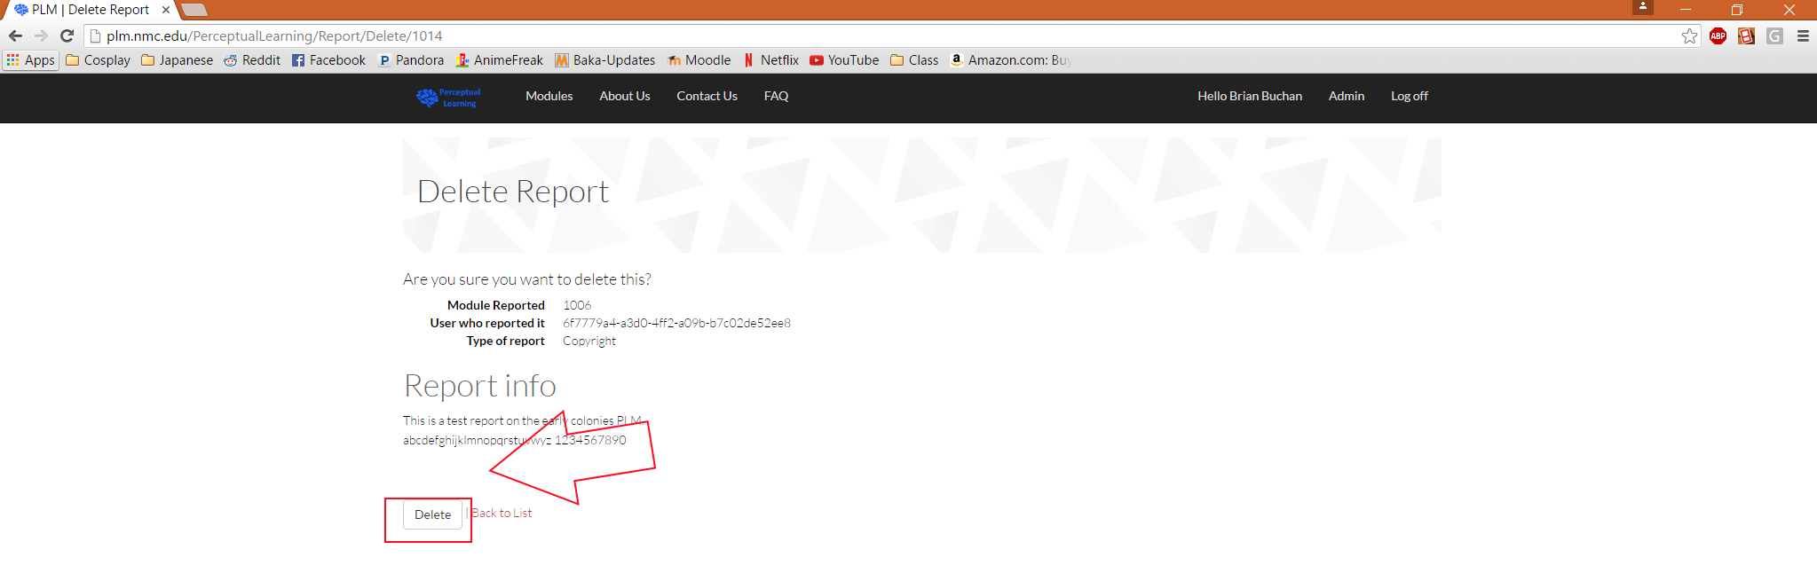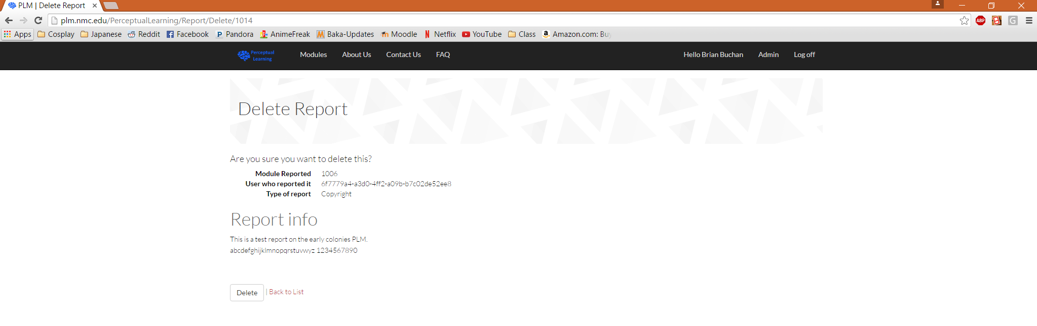If you are sure that you would like to delete the report, then you can click the ‘Delete’ button to finalize your decision.
* Once you click the ‘Delete’ button the report will be removed and you will be navigated back to the ‘Reports Administration’ page.